ADST ORAL HISTORY LESSON PLAN: Female Code Breaker Betty Allan
Middle School Grades 6‐8
High School Grades 9-12

Big Idea: Oral history is a tool for learning about people, places, and events. Diplomats have a front-seat perspective on many international historical events.

Topics
- Diplomatic Oral Histories
- U.S. Foreign Policy
- 20th Century U.S. and World History

Description: Students explore how historians use primary source oral histories to understand events, people, and places from the past. They will read the oral history of Betty Allan, a female code-breaker from WWII from the Association of Diplomatic Studies and Training (ADST) diplomatic oral history collection, and conduct a critical analysis of the interview in order to better understand her experiences described. Students are encouraged to make connections between the experiences described in the oral history and their own lives.

[Teachers: Please note that this sample unit is for the Female Code Breakers during WWII but this lesson and format can be used with any historical events on our site, adst.org, by searching the event in Fascinating Figures or our Country Reader Series by country.]

Objectives:
Students will:
− Understand oral history as a primary source as a way of gathering detailed information that
helps us understand a specific time, place, person, or event.
− Connect past and present experiences.
− Understand that perspectives of events change over time.
− Understand that all of us have important stories to tell and perspectives to
share.

Skills:
- Identify, analyze, and interpret primary sources to make generalizations about events and life in world history
- Evaluate the authenticity, authority, and credibility of sources
- Develop perspectives of time and place

Standards
This unit is aligned with the following Virginia Department of Education History and Social Science Standards of Learning:

- World History and Geography: 1500 A.D. (C.E.) to the Present
The Modern Era
WHII.10, WHII.11

- The United States 1865-present
Turmoil and Change: 1890s- to 1945
USII.1, USII.7, USII.8

Virginia and United States Government
GOVT.1, GOVT.7, GOVT.12

Virginia and United States History
VUS.1, VUS.11, VUS.12

- Civics and Economics
CE.1, CE.3, CE.4

Using Primary Sources
Primary sources are the raw materials of history — original documents which were created at the time under study. They are different from secondary sources, accounts or interpretations of events created by someone without firsthand experience, such as textbooks.

Examining primary sources gives students a powerful sense of history and the complexity of the past. Helping students analyze primary sources can also guide them toward higher-order thinking and better critical thinking and analysis skills.

Essential Questions:
− How do historians learn about the past?
− How can the past inform our understanding about the present?
− How can one’s understanding of an event change over time?
− How are historical accounts influenced by the biases of eyewitnesses?

Time Frame:
1‐3 class periods. This activity has been designed to be customized to your learning goals and your students’ individual needs. Choose to do the complete lesson plan or select parts with your students based on your schedule and objectives.

Materials:
- This unit relates to the Female Code Breakers, but this lesson can be used with any international historical event from post WWII-present by searching our site by that historical event. Find content related to your curriculum at ADST’s website in Moments in Diplomatic History, Fascinating Figures, written or podcast Oral Histories, or Country Readers which often have different perspectives on the same event (available at http://adst.org/oral-history/#.WgyWSkqnGUk).
- Make copies of Betty Allan’s Oral History in the Appendix.
- Student Worksheets – choose among the following and distribute to the class:
- Document Anaylsis Worksheet (www.archives.gov)
- Appendix: Female Code Breaker Oral History and Resources
  - ADST Oral History – Betty Allan, Army Signal Corps, 1944-45
  - Photos of Arlington Hall and Female Code Breakers
  - 6/15/1942 Letter to Arlington Hall Alumnae
  - Virginia Living article: Social Graces and Espionage
  - Smithsonian Magazine article: How the American Women Codebreakers of WWII Helped Win the War
  - CNN article: Female Code Breakers: The Hidden Figures of the Greatest Generation
  - YouTube movie: State Department: File 649

Vocabulary:
− Oral History
− Perspective
− Bias

Procedure:
Pre‐Lesson Prep (to be completed before the day of the lesson):
- Prepare the photos and choose among articles provided in the Appendix to share with the class on female code breakers’ as background.
- Prepare copies of ADST’s Oral History of Betty Allan for class.

Part 1: Introduction
- Ask students if they know any childhood stories about their grandparents related to the historical event being studied -- in this case, World War II.
- Instruct students to share those stories with someone sitting next to them.
- Ask a few students to share their stories with the class.
- Ask students how they know about those stories if they were not alive when those
stories took place. Reinforce that information is often received through stories that
people tell each other. Option: Ask for 5-6 volunteers to play the game of Telephone. Tell the first student a brief story and then compare the first and final versions to illustrate the need for an objective eye when reading first-person accounts.
- Connect the exercise to the work of historians. Explain to students that historians learn
about the past by asking people to tell them stories about it. These stories are called
oral histories.

Part 2: Activity
- Tell students that in today’s lesson they will read an oral history of a female code breaker from Arlington Hall, to learn what it was like for women during WWII, using the Document Analysis worksheet attachment. Have students complete the Document Analysis worksheet and review as a class.
- Show the images in the Appendix to the class to set the stage and give them visuals of the historical setting before reading the oral history.
- Distribute copies of oral history transcripts of Betty Allan from the Appendix to read individually or as a class. Ask students to pay close attention to clues that help us understand how Betty Allan felt about her experience serving as a code breaker.
- Ask students what they learned about each of the experiences of the female code breakers and record students’ observations on the board.
- Have students attribute adjectives to describe the ideas and feelings captured within the oral history. Guiding questions might include:
- What do you think it would feel like to be placed in Washington, DC during wartime, away from your family and friends for several years?
- How might that help us understand her experiences?
- What do you think it would feel like to use math to complete your job without knowing how it fit into the bigger puzzle? How might that help us understand the code breakers’ experience?
- Has anyone in class had a story from childhood that they retold again and again? How has your telling of stories changed over the years?
- What does this tell us about how we should think about oral histories?
- Can we take them as absolute truth?

Part 3: Wrap‐Up
- Instruct students to write a short paragraph reflecting on the experience of being a female code breaker during WWII. In what ways did reading this oral history add a dimension to their understanding of the war effort after this activity?
- Encourage students to think about the oral history of Betty Allan whenever they think of this historical event.

Assessment:
- Review the students’ reflective writing.
- Note what kind of details students were able to pull out from the oral history. Did students pick up on how Betty Allan might have felt?
- Note whether or not students were able to make personal connections to her story.

Extensions:
- Have students interview a family member or visit a senior living center member about their experiences with the same historical event (WWII) and include that additional perspective in their essays.
- Consider showing clips of the 1949 movie State Department: File 649 (available on YouTube) to the class for an historical view of diplomatic life in the U.S. Foreign Service near the time of this oral history.

Bibliography:

Carr, Jane. “Female Code Breakers: The Hidden Figures of the Greatest Generation.” CNN, Cable News
Network, 11 Oct. 2017, www.cnn.com/2017/10/11/opinions/code-girls-iiza-mundy-opinion/index.html.

Editor, Web. “Code Girls and Arlington Hall: A Diverse History.” Arlington Public Library, 20 Nov. 2017,
library.arlingtonva.us/2017/10/24/code-girls-and-arlington-hall-a-diverse-history/.

Kennedy, Stuart. “ADST Oral History Intervew of Betty Allan.” 13 Aug. 2013, pp. 1–18. Association for
Diplomatic Studies and Training, adst.org/wp-content/uploads/2013/12/Allan-Betty.pdf. Accessed 12 Dec. 2017.

Kovach, Karen. Breaking Codes, Breaking Barriers: the WACs of the Signal Security Agency, World War II.
History Office, Office of the Chief of Staff, US Army Intelligence and Security Command, 2001.

Mundy, Liza. Code Girls: the Untold Story of the American Women Code Breakers of World War II.
Hachette Books, 2017.

Newfield, Sam, director. State Department File 649. 1949, www.youtube.com/watch?v=NVkkb9rnoLs.

Virginica, Compendia. “Social Graces and Espionage.” VirginiaLiving.com, 22 Apr. 2011,
www.virginialiving.com/culture/social-graces-and-espionage/.

Wei-Haas, Maya. “How the American Women Codebreakers of WWII Helped Win the War.”
Smithsonian.com, Smithsonian Institution, 5 Oct. 2017, www.smithsonianmag.com/history/how-women-codebreakers-wwii-helped-win-war-180965058/.

Appendix: Oral History- Female Code Breaker Betty allan

BETTY ALLAN
Breaking Japanese army and navy codes
Army Signal Corps, Arlington Hall, VA
Washington, DC (1944-1955)

Today is the 16th of August, 2013. This is being done in Arlington Hall, former
Cryptography Center of the Army, which is now part of the Department of State’s
training center. And the purpose of this interview is to get information regarding the
work here at Arlington Hall prior to the arrival of the State Department. And Betty Allan
served here during the war; we want to pick up her wartime experiences. She was interviewed on August 16, 2013 by Charles Stuart Kennedy.

EXCERPT

Q: […]Was this sort of unusual for a young girl to be that good in math?

ALLAN: Well, there were others who were good in math too, but through high school I
took a lot of math. And then when I went to college, Albany State Teachers College, I
majored in math and social studies and was prepared to teach math and social studies in
high school. And of course that’s why they were interested in me in the Army Signal
Corps.

Q: Well, let’s talk a little bit about high school. Did you find there was a difference in
education in a public high school as compared to a parochial school?

ALLAN: I expect not, no. My brother went to a public elementary school part of the
time because he and the nuns didn’t get along. A number of Indian students joined us in
the Salamanca public high school from an Indian elementary school outside of
Salamanca.

Q: Were you pointed towards teaching?

ALLAN: Yes. I went to a teacher’s college. My family wanted their daughter to be
educated and teaching was an honored position in their eyes and mine. I thought I would
like teaching.

Q: Where did you go to teacher’s college?

ALLAN: Albany, New York. Albany State Teacher’s College it was called then. Now
it’s the University of New York State at Albany.

Q: How far up in mathematics did you go?

ALLAN: Trigonometry, advanced geometry, advanced algebra, statistics and so forth. I
was prepared to teach algebra and geometry in high school.

Q: How old were you when World War II started for us as December 7th, 1941?

ALLAN: I was 18 since my birthday was in June. And I graduated from college when I
was 21.

Q: What brought you to work for the military?

ALLAN: I confess I never thought of working for the military (laughs). But I had no
desire, having been interviewed at various parts of the state, to teach math in small towns
and live in rental digs perhaps over the local funeral parlor. Also, the salary was not great
of course and small towns were very strict about how teachers conducted themselves.
Also, my father was acquainted with the school board in Salamanca. They assured him
that I could have a math teaching job if I applied. And he said, “Isn’t it wonderful? You
can take Miss Champlan’s place.” Miss Champlan had taught him and she’d taught me
math -- she was an admirable and a formidable lady (laughs). Since her demise they had
preferred men math teachers but the men had been drafted in the war.

Q: Yes.

ALLAN: So he said, “You could be a Miss Champlan and you could live at home.” I had
a very peaceful, nice home and childhood. I would not have objected too much to living
at home, but I objected to living in Salamanca -- I wanted some adventure, I wanted to go
elsewhere.

Q: Oh yes.

ALLAN: Well, there were some recruiters who came from Washington to the college. I
don’t know whether they were just recruiters in general who were scouting for various
agencies, or whether it was for the Army Signal Corps specifically. I somehow missed
the recruiters so I just wrote to Washington and asked what jobs were available. I was
contacted by the Army Signal Corps. I didn’t know what the Army signal Corps was at
the time. I went for interviews in New York State and then got on a train as my account
here will tell you, and came down to Washington. My father had passes on the railroad,
so I could just hop on a train there in Salamanca and come down to Washington.

Q: You wrote an account of this saying you got all dressed up and, you know, going to
business meeting on the train. And it was in the middle of summer?

ALLAN: Yes, and it was an overnight trip. I didn’t have a seat part of the time, because
of the number of troops on the train.

Q: Oh yes, I remember that.

ALLAN: Sitting on suitcases in the aisles was common.

Q: Troops –

ALLAN: Yeah.

Q: You were lucky if you ever got a seat on a train. I stood in the aisles many a day,
many a time.

ALLAN: Yes.

Q: So you were a pretty wilted young lady when you –

ALLAN: That’s right. (laughs) I was. And I was surprised at the reception at Union
Station in Washington.

Q: What sort of reception was it?

ALLAN: Well, we were supposed to meet at a certain place and we were gathered
together by this WAC (Women’s Army Corps) who took us out in the parking lot and put
us in an open army Jeep sort of truck. We sat on either side of the jeep truck. The WAC
driver stopped along the way, Fort Meyer or some place, and spent some time while we
sat in the hot sun. I wasn’t used to the heat of July in Washington. And then she brought
us out to Arlington Hall, out into the Virginia countryside. I didn’t know where we were
going. And there we were photographed and were interviewed and they talked about
training. I wrote about my experiences for a project years later at the Woman’s National
Democratic Club in Washington, DC.

Q: Well just, you can read –

ALLAN: I’ll read this, which is a shorter version of one I had written for my memoirs.

Q: Good.

ALLAN: The project was to feature the stories of members of the Democratic Club
who’d served in the war. I wrote: As you requested in our phone conversation I have put
down a few sentences related to my government-related war service. You may use it as
you see fit. I am not sensitive and neither is the U.S. government security at this date.
Having just graduated with a BA (bachelor of arts) from the Albany State Teachers
College, later the New York State University of Albany, in early July of 1944 I presented
myself at Union Station in Washington DC as instructed by the U.S. Army Signal Corps.
I had been interviewed by a U.S. government recruiter, filled out a number of forms, and
had been summoned by the corps to Washington to undergo further testing, a security
check, and training for a position with the corps. They indicated they were interested in
me because of my math background. I was qualified to teach high school math. After
having been interviewed for high school teaching jobs in several small towns around the
State it became apparent to me that I would vastly prefer the excitement of going to
Washington to work for the war effort.

From July 1944 until the Japanese surrender in August 1945, my job at the headquarters
at the Army Signal Corps at Arlington Hall in Virginia was code breaking, attempting to
decipher the military communications of the Japanese Armed Forces in the Far East. It
was an exciting job under sometimes stressful conditions, but it was also an exciting time.
We worked in low temporary barracks-like, non-air conditioned buildings on three shifts.
And after that I stayed on another five plus years at Arlington Hall, the Army Signal
Corps having evolved into the National Security Agency, working on Soviet Union
communications in the Cold War.

It might be of some interest to add something about how I experienced life in Washington
in wartimes. For my first appearance in Washington I dressed very carefully in dark blue
suit with white lace at the neck, matched by a little lace hat and snowy white gloves.
After a night sitting up on the train some of the starch was gone, but I thought I looked
very presentable. I and a few other recruits were greeted by a WAC in uniform and
immediately loaded into the open back of a small army truck for a trip out to an unknown
destination in the Virginia countryside. It was a terribly hot July day. We made a stop or
two along the way while the WAC made some deliveries and we waited in the sun. After
arrival at Arlington Hall we were unloaded from the truck and ushered into low
temporary buildings.

Arlington Hall in its pre-war days had been a select girls school. Its lovely main building
had been converted into an army headquarters, and a number of temporary structures
were scattered about the extensive grounds. In the 90 degree heat we were given a series
of lectures, filled out forms, and then were unceremoniously thrust in front of a camera to
have a picture taken for our badges which were to be worn at all times when on the
grounds. For six years I wore that sad badge around my neck.

After all this, those of us who did not already have a place to stay were taken by bus to
Arlington Farms, which was located near Memorial Bridge and across the river from the
Lincoln Monument. Arlington Farms was actually on the sight where the Department of
Agriculture once had an experimental farm, thus its name. Several dormitories had been
constructed in this location to house the great number of new governmental employees
who’d come to Washington to work in the war effort. I was shown to my 10 by 10-foot
room that was equipped with a chair, small desk and chair, cot, and small closet.

Washroom, bathrooms, and laundry were down the hall. On the grounds was a cafeteria,
an infirmary, a small department store, and a beauty parlor. Housing was extremely tight
in DC and in Northern Virginia at the time, and many lived there for months or even
years before finding other quarters.

It was a very convenient location for getting to work or almost anywhere in Washington.
We could walk over Memorial Bridge to see Washington sites or to attend a Washington
National Symphony Concert held in the summer on a barge drawn up to Potomac shore
in the shadow of the bridge.

Now, out here at Arlington Hall we walked down a long road to our barrack-like structure
where we worked. And on the grounds were several other buildings. There were
dormitories or barracks for WAC’s, and some of them worked with us. And they had
really a rough life because their barracks were not heated except for a potbellied stove at
one end, which they had to get up in the morning to stoke. And then they had their
breakfast and were delivered to the other temporary buildings. On the grounds was a
cafeteria and I remember we had to walk outside the building we worked in to eat. We
could have three meals a day actually. I worked a swing shift in the beginning, lived at
Arlington Farms first. We were picked up by a bus and brought out. Later I lived in
rental rooms in Buckingham.

Q: Ah yes. That’s not far from here.

ALLAN: When I lived in Buckingham in rental rooms, I walked through the cemetery,
across the highway or along the highway, a dangerous business in the darkness.

Q: Well, let’s talk about the work you were doing. What did your work comprise of?

ALLAN: Well, we worked at tables in a fairly small room when I was on the swing shift.
We had a military supervisor at first and later a civilian woman over us. Early on we
worked with what were called overlays where we would move numbers or letters over the
coded Japanese messages that were written in katakana, a syllabic form of Japanese
writing. We had training to recognize military titles and military terms in Japanese. And
if we saw a match we would holler out, “We think we see the beginnings of a word or we
see a recognizable title or word appearing.”

And our supervisor would come over, and if she thought it was a breakthrough she would
yell, “Hot spit,” (laughs) and we would all be elated.

Q: Ah. Well, you were working mainly on navy?

ALLAN: No, army and navy I believe. My memory’s a little dim about that. But then
came the computers of course which changed everything.

Q: Did the computer come during your time?

ALLAN: Yes. Came I think in ’46 when I was working on Russian messages. I
remember having a lecture by a German woman -- I don’t see it mentioned anywhere in
this literature that I’ve been reading -- who was an expert in computers. We were given a
tour of the computer room, a gigantic refrigerated room. The only refrigerated place on
the property. A great number of huge machines all working at once, were making a quite
a racket and spewing out reams of paper.

Q: Yeah.

ALLAN: We would be given these machine runs and we would go through them to see if
there was anything that seemed recognizable. At this time we worked at desks in large
rooms.

After the Japanese War ended a number of us moved into the Russian Cold War
operation. That’s all part of this history here. Let’s see. After the surrender of Japan in
August of ’45 I worked with the Russian unit. I had many Russian language courses at
the agency and spent the summer of 1947 at Columbia University in New York studying
at their Slavic Language Department. During this period I moved several times and had
many experiences. After six years at the agency I was ready to do something else. And
that leads to further tales. And I believe I contributed in some ways to the successful
outcome of World War II, certainly my decision to abandon the teaching profession at
least temporarily changed the course of my life and I believe happily so.

Q: Well now, I may as well continue, but I’d like to know a little bit more about your time
here at Arlington.

ALLAN: Yes.

Q: What was the atmosphere like for a young woman here?

ALLAN: Well, it was fairly exciting in the early days, but after computers took over
there were long periods of boredom, days while you just went over pages and pages of
machine runs. I do remember for at least a month another girl and I wrote a codebook.
And we did this by just taking numbers, adding a certain number or subtracting a certain
number, and doing it with every number from one to 100. That somehow became a code
book. After that the encryptors would do other things with the codes. They could put
them in a machine and scramble them. It was very difficult to decode messages that were
encrypted with what was called “one time pad”.

Q: Well, were you working mainly at night?

ALLAN: No, I was working mainly in the daytime. But I did work that swing shift for a
number of months for the Japanese code breaking operation.

Q: Well, what about nights? I mean what was the social life like? Because I would think
you’d need a social life to sort of, you know, loosen up after this very intense work.

ALLAN: Well, mainly you had a social life with your compatriots. You lived often with
other Arlington Hall people. I lived in an apartment in Georgetown for years with two
Arlington Hall girls and all three of us dated Arlington Hall men. Two of the three
married Arlington Hall employees. Of course there were numerous cultural things to do
in Washington – concerts, ballet, movies – to enjoy.

Q: Mm-hmm.

ALLAN: We socialized with the spy, Bill Weisband who was revealed to have done the
most damage to the United States perhaps of any spy. Well, here he is. Here’s a picture
of him.

Q: Who is that?

ALLAN: Bill Weisband. And I didn’t know that he was a spy for many, many years after
I left the Signal Corp. I worked very closely with him because he was an expert in
Russian language. At this time we sat at desks in a large room. And if you needed help
with the Russian text you’d put up your hand and Bill Weisband would come and help
you with it, interpret what it might be saying. And this went on for a couple of years. He
also came to our apartment in Georgetown for parties. He was part of our social set. He
had an accent and was supposedly from Hungary I think, but he spoke Russian very well.
He had parents in New York who were in the gem business and he used to walk around,
especially when he came to parties, with loose gems in his pocket. And he’d show you
these gems. Once in a while he would present you with one of them, unset gems.

Q: Oh.

ALLAN: When I left the Agency in 1950 and then I didn’t know what happened to him.
My roommate dated and then married the head of personnel here at Arlington Hall,
Maurice Klein. His secretary married Bill Weisband and he was best man at their
wedding. Well, “Mo” Klein lost his job and I didn’t know why. Somebody said it was
something to do with his misrepresenting his educational background. He said that he
graduated from Columbia University when actually he only attended there. That was the
grounds on which they dismissed him according to rumor. There was never any
indication that he was implicated in any way with Bill Weisband’s activity.

Q: Uh-huh.

ALLAN: Actually it was because they had discovered Bill Weisband was a spy and a
very seriously damaging spy. And Klein, having been a very good friend of his, was
suspect, I suppose. When I went to the CIA (Central Intelligence Agency) after having
left the job here (Arlington Hall), it took me quite a long time to get clearance and I
didn’t know why. I think it might have been my association with this spy.

Q: Was there -- I mean did everybody go out and have -- I was just thinking because of
the hard work and all I would think that it would be attractive to go out and, you know,
drink quite a bit and all that.

ALLAN: Well, we partied a lot but there was not a great deal of drinking. It was fun
living in Georgetown (laughs).

Q: Were there many military on the base here or?

ALLAN: Yes, there were. The name of the agency changed. It didn’t just go directly to
the name: National Security Agency. While I was there as a matter of fact the name
changed from Army Service Forces Signal Security Agency to the Department of
Defense Armed Forces Security Agency.

Q: Here in Arlington when the Japanese surrendered in the summer of ’45 -- did you see
that as the end of your job, or?

ALLAN: No. I had no worries about it.

[…]

Q: What was the Arlington Hall as a physical facility like at the time?

ALLAN: Well, there were the headquarters which I didn’t get near. Once in the gate I
walked down a long road to temporary buildings and I don’t know how many of them
there were, but I think there were a number. And I think I was moved from one to the
other when I went from Japanese to Russian, but I’m not positive about that. There also
were the barracks for the WACs. And I think for military men as well. And a cafeteria
open 24 hours a day. I don’t know very much about the entire facility, to tell you the
truth.

Q: Were you ever tempted to join the WAC’s?

ALLAN: No, it never occurred to me. I didn’t even know about them I guess until I
encountered them here.

Q: Because you weren’t under military discipline.

ALLAN: No. Never.

Q: I was noticing in your pay grade, just for somebody wanting to do this -- we have
some pay things that you were hired as a cryptanalytic aid at $1,800 per annum.

ALLAN: Mm-hmm.

Q: And then you moved up to $2,000 per annum, and then $2,320 per annum, and then to
$3,021 per annum for the Army Security Agency in 1947. And I guess ’48 you were a
research analyst. You were getting $3,397.20 per annum.

ALLAN: While I was there the name changed from the U.S. Army Service Force Signal
Security Agency to the Armed Forces Security Agency. My title went from Cryptanalytic
aide to Research Analyst to Research Analytic Specialist.

[…]

Q: Times have changed, but when asked to put that into real dollars, which is not quite as
bad as it sounds today. Well, Betty I think this has been very interesting.

End of interview

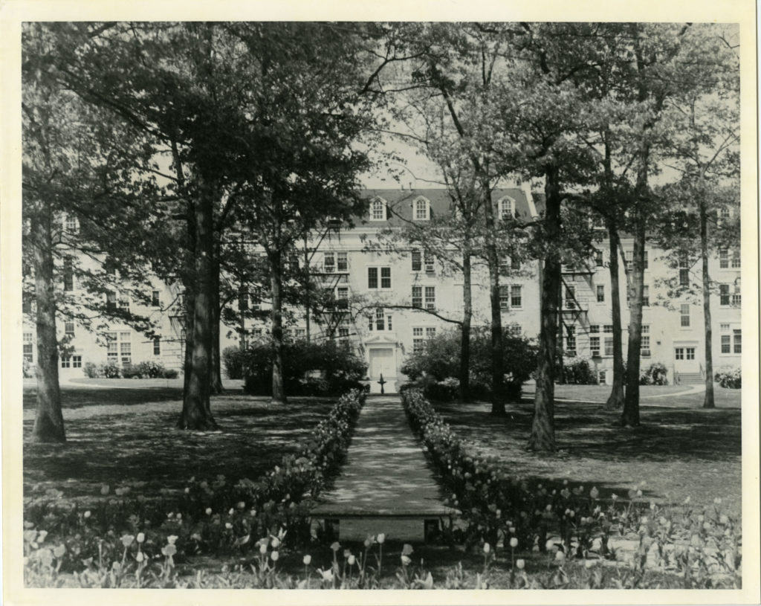
Arlington Hall, c. 1940
Exterior of Arlington Hall girls school, ca. 1940. From the late 1927 to 1942, Arlington Hall was a private educational institution in Arlington, Virginia. It was a Junior College as well as a four-year boarding high school. In 1930, the school was known for its thorough instruction, recreational features and manicured landscaping. The main building housed administrative offices, classrooms, and a dormitory. It quickly became a beloved and well-known accredited institution for upper-class women around the country.
(Source: Arlington Public Library)

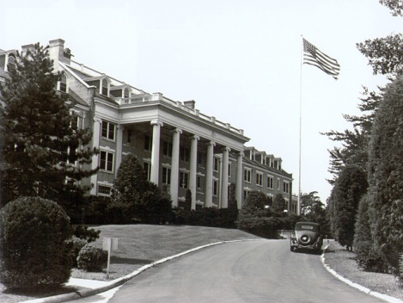
Arlington Hall
(Source: Wikipedia)
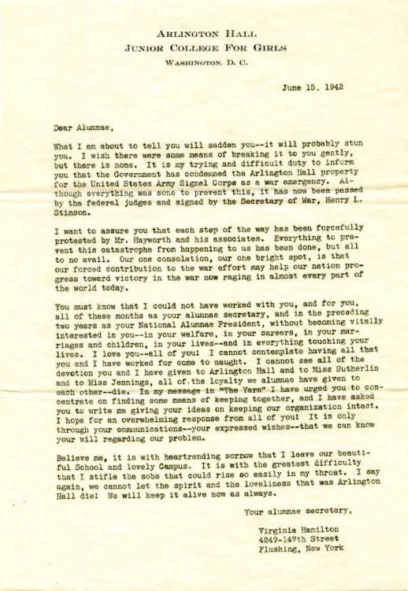
Letter to Arlington Hall Girls School alumnae from Virginia Hamilton on the school being requisitioned by the US Army, 6/15/1942.
The Army “invoked the War Powers Act and seized the acreage, paying the trustees of Arlington Hall $650,000, a sum that barely covered the mortgage.” Once it was commandeered in June 1942, Arlington Hall became known as Arlington Hall Station. Although this was an Army instillation, civilians outnumbered military personnel. Less than a year after becoming “Arlington Hall Station,” over 2,300 civilians worked on the compound while the Army only had fewer than 800 military employees. (Source: Arlington Public Library)
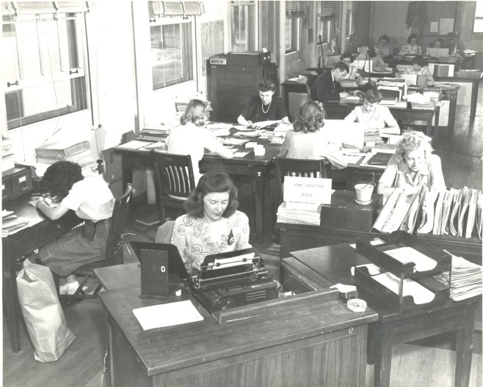
Arlington Hall Female Code Breakers
(Source: Arlington Historical Society)

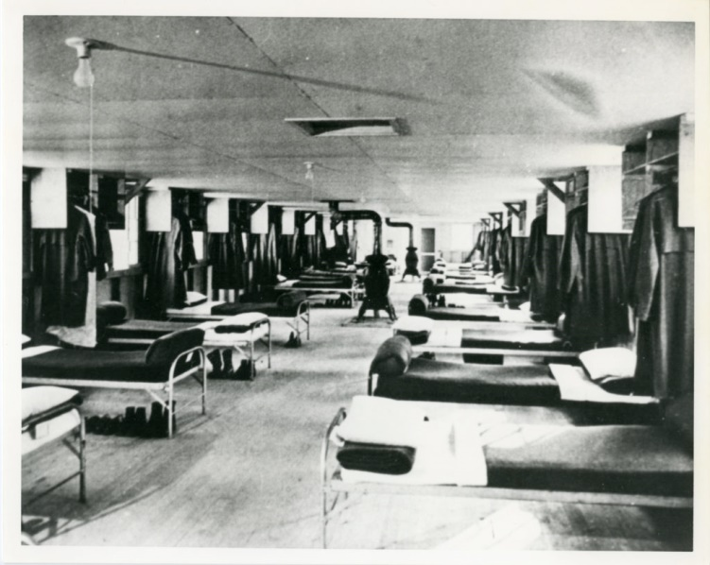Arlington Hall Station barracks, 1940s.
Excerpt from Breaking Codes Breaking Barriers, by Kathy Kovach, page 16: “By the end of December 1943, the WAC detachment of the 2d SSB at the Hall stood at about 225. The enlisted women were initially housed in one-story enlisted men’s barracks. Ann Brown was assigned to Arlington Hall in the early years: “We were assigned 20 to a room. We had pot-bellied stoves at either end we had to tend. The new barracks were built of concrete block which held the summer heat. Many women, especially those living on the second floor, pulled their mattresses outdoors to sleep, returning them back inside each morning.”

(Source: Arlington Public Library)

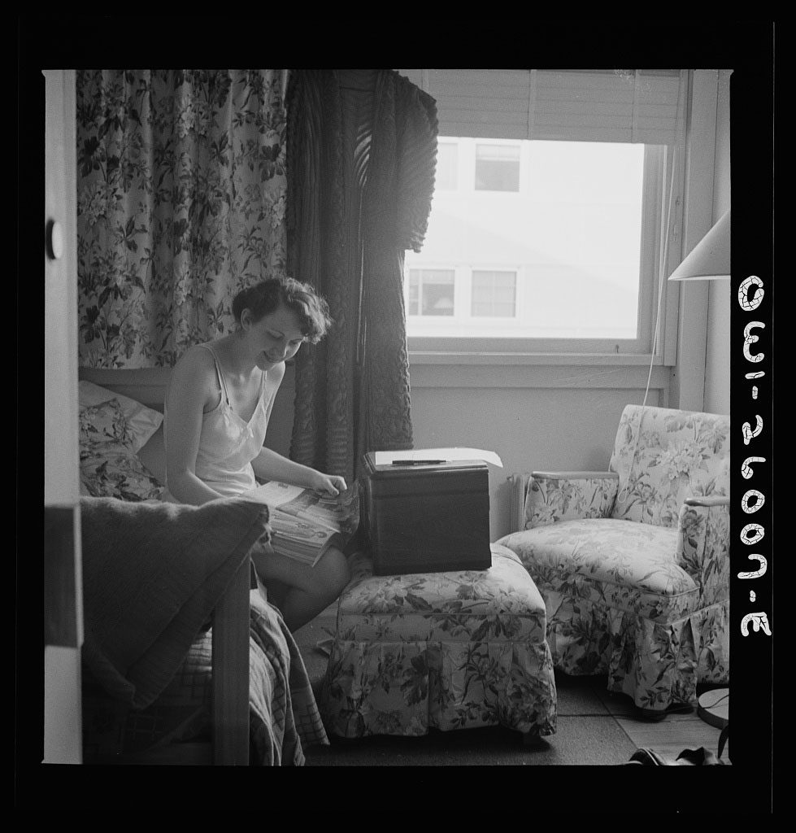
Arlington Farm Dorm Life
Excerpt from Code Girls – The Untold Story of the American Women Code Breakers of World War II by Liza Mundy, page 47: “At Arlington Farms, women could take meals in the cafeteria and send their clothes to be laundered or dry-cleaned. Maids cleaned their rooms weekly. There were pianos and snack bars, and little cubbyholes meant to resemble the “dating booths” of American drugstores. Each dormitory was named after an American state.”
(Image Source: Library of Congress)

VIRGINIA LIVING MAGAZINE

Social Graces and Espionage
by Compendia Virginica
APRIL 22, 2011 10:39 AM
How did a women's finishing school become a center for U.S. code-breaking efforts during World War II? An idyllic tale of espionage.
Arlington Hall Junior College’s brochure effused: “The natural attractions are enhanced by artistic plantings of boxwoods, tall cedars, rare evergreens, and a wealth of flowering shrubs. . . . The Colonial atmosphere of Arlington Hall is emphasized by the beautiful buildings of cream-colored brick with stately white columns. . . The social life of the college is calculated to implant in the minds and hearts of the girls the highest ideals, and to develop those graces and powers that result in social efficiency.”
Six miles outside Washington, D.C., one hundred serene, wooded acres seemed ideal for a girls’ school. By 1927 Arlington Hall Junior College was established, with peony-lined flagstone walks, a lily pond for canoeing, bridal paths, riding facilities and sculpted footbridges. The main building hearkened to the architecture of Thomas Jefferson’s University of Virginia. Two little villages were nearby: Ballston and Clarendon. For cultural excursions, there were the hallowed institutions of the nation’s capitol.
All rolled along pretty well, the student body growing and the grounds becoming ever more delightful until Wall Street’s house of cards collapsed and the Great Depression spread economic woe across the land. Enrollment stagnated, the faculty worked for room and board only and parents were late sending tuition payments. Arlington Hall Junior College staggered through the 1930s, barely viable.
Then came the trauma of Pearl Harbor. On December 7, 1941, the U.S. was jolted out of its official neutrality in a world wracked by war. Suddenly Japan might be invading Los Angeles and Nazis bombing Atlantic-coast cities; anything could happen. But one thing was sure: The U.S. Armed Forces were going to ramp up in a huge way, and nearly everyone was going to be engaged in a war effort to expunge Nazism in Europe and press back an aggressive Japan. Already the War Department was constructing the largest office building in the world across the Potomac from the nation’s capitol, to be dubbed the Pentagon. But the five-ringed colossus would not be ready for a year, and the World War I “temporary” Munitions Building on the mall near the Lincoln Memorial was nearly bursting with fresh men and women for the war effort.
Few could be fooled into believing the United States was ready for a major two-front war. Its Army was small and hidebound, its Navy only recently buoyed with new orders for ships, and its factories either idle or producing peacetime goods. Smaller yet, and probably less well-known than any portion of the Armed Services, were the branches intercepting and attempting to decode the wireless messages of foreign countries. The Army’s office for decryption, the Signals Intelligence Service (SIS), was housed in the dreadful Munitions Building (demolished in 1971 to create Constitution Gardens just east of the Vietnam Veterans Memorial).
With only a handful of employees, headed by the brilliant William Friedman and rivaled somewhat by its Navy counterpart called OP-20-G, SIS had begun the dangerous year of 1940 by improving its relationship with British code breakers secretly headquartered north of London at an estate called Bletchley Park. Friedman had led the effort to crack the Japanese diplomatic code, which the Americans called “Purple,” in 1940, a feat that led to clues Japan meant to attack the United States.
Only months after Pearl Harbor, the SIS was activating a radio wave listening station under construction at Vint Hill Farms near Warrenton. One day in April 1942, according to the U.S. Army’s History of Arlington Hall Station, several SIS officers were returning from Vint Hill to the Munitions Buildings when they spotted the rolling acres near North Glebe Road in Arlington. A little probing revealed that the acreage belonged to Arlington Hall Junior College. Here was a grand step up from the dreary Munitions Building: tennis courts, a gymnasium and the classic-Virginia main building. What’s more, since the estate was outside of Washington, it was thought to be less vulnerable to enemy sabotage and spies.
The Army rapidly discovered that the girls’ school was in financial straits and made an approach. The trustees were willing to lease the school to the Army for the duration of the war, but the SIS was not inclined to let such a plum slip from its fingers. The Army invoked the War Powers Act and seized the acreage, paying the trustees $650,000, a sum that barely covered the mortgage. The Army did not anguish over grace nor did it lose much time: It immediately filed a Declaration of Take in Federal District Court. Then, on June 10, only weeks after the officers returning from Vint Hill had spotted it, the Army sent 2nd Lt. G. Runkle armed with a .45-caliber pistol and accompanied by 14 enlisted men shouldering broomsticks in place of scarce rifles to properly commandeer the place. When they arrived, some girls were still in their dormitory rooms. (In similar fashion the Navy’s OP-20-G used the War Powers Act to seize a women’s college at the corner of Nebraska and Massachusetts Avenues in the District; they still have it.)
Not long after, the women were out of Arlington Hall’s grand buildings and the military was in. Soldiers erected double barbed-wire fences around the property. Access to the grounds was limited to four gates. According to some documents, here began the first badge system: No one was permitted on the grounds without first showing the proper ID. According to the Army’s historical account, shuttle buses moved hourly between Arlington Hall and the Munitions Building. The code breakers shoved their coveted Purple Machine, by which they were reading the Japanese diplomatic code, into a former dormitory room attached to the only working bathroom on the second floor. According to the book Battle of Wits, written by Stephen Budiansky and published in 2002, persons on the floor were allowed to use the facilities just once an hour —but only after the Purple Machine was temporarily draped so no non-Purple people could see it.
The columned main school building was redubbed the Headquarters Building, but even more space was needed, and so construction of new facilities began almost immediately. Earth-moving equipment obliterated swaths and swales, and concrete trucks poured foundations. Walls went up. Some of the thirteen prospective barracks planned for enlisted men were ready by Halloween. The new buildings—the largest were called Building A and Building B—were as drab as the old Munitions Building, but they had the advantage of being less crowded, and an outdoor smoke offered a view of greenery rather than Constitution Avenue.
Although Arlington Hall Station (AHS), as it came to be known, was an Army installation, civilians outnumbered military personnel. Less than a year after the takeover, 2,300 civilians worked at the compound while the Army employed fewer than 800. For a military installation, the culture was casual. Many of the civilian code breakers were young, bright and somewhat off-beat, just the sort resistant to military regimentation. Military hierarchy was neglected; respect hinged on cryptologic skill whether one was a civilian, a private or a lieutenant colonel. The same applied to gender. Many of the new recruits were women—civilian and, later, WACs (recruits of the Women’s Army Corps). Perhaps not a few of these new hands only months before had taken typing classes there or debated the poetry of Percy Bysshe Shelley.
Whatever the pre-Pearl Harbor lives of those who worked at Arlington Hall Station, their new efforts were vital and prodigious. SIS concentrated on Japanese traffic, and it was work out of Arlington Hall Station that gave Allied commanders hints of Hitler’s plans for invading Russia (from messages by Japanese diplomats) and Hitler’s mistaken belief that the Allies’ main attack of 1944 would come at Calais instead of Normandy. SIS also oversaw work on the SIGABA machine, the Americans’ counterpart to the German Enigma cipher device. It was never cracked by the nation’s enemies.
In 1943, SIS worked hard at breaking Japanese army codes, as opposed to those of the diplomatic corps, and according to Budiansky’s book, by the end of the year had made excellent progress. Soon the Americans were reading thousands of Japanese army messages as fast as or faster than Japanese officers were. As at Bletchley Park in England, most of the Army code breakers were women. In Battle of Wits, Budiansky cites a report on the AHS code breaking at the end of the war that read: “It was proven over and over again that women were far better equipped than men for the routine but detailed work.”
In 1943, SIS changed its name to the Signal Security Agency (SSA). That year, a small and highly secret SSA group turned its attention to Russian codes. A growing number of Soviets had entered the U.S. to assist with lend-lease goods shipped to Russia, and authorities worried some were agents snooping for secrets. This code work came to be called Venona, and according to Battle of Wits it indeed began to reveal a sophisticated Russian intelligence operation in the U.S.
By V-J Day, Arlington Hall Station had become massive, employing 5,700 civilians, more than 1,000 military officers and men and 1,000 WACs. But with peace at hand most of them were eager to move on. Within months, only 35 WACs remained. Both military and civilian ranks shrank. But no one thought that code breaking was no longer needed. SSA became the Army Security Agency (ASA) and continued with its Russian codes efforts, and positioned itself to be in the thick of the Cold War.
Not surprisingly, Arlington Hall Station was not immune from serious gaffes. Its work was sniffed out by foreign intelligence networks. In 1990 it was revealed that William Weisband, who worked in SSA’s Russian section as early as 1943, had been a spy for the Russians. Beginning in 1949, British intelligence officer Kim Philby was regularly granted access to AHS; then in 1962 it was deduced that he’d been a Soviet spy.
Despite those mistakes, from the late 1940s through the 1950s, Venona was a vitally important U.S. asset in the rivalry with the Soviet Union. Indeed, Venona-decrypted messages strengthened the cases against Alger Hiss, Julius Rosenberg and others, and helped show that the Soviets had penetrated the Los Alamos nuclear bomb complex. (Ironically, their messages could not be used in courts of law, or even revealed, because doing so would demonstrate the success of U.S. code breakers.)
In 1949, rival cryptologist services of the Army and the Navy joined to form the Armed Forces Security Agency (AFSA), which in 1952 evolved into the National Security Agency (NSA). The NSA retained Arlington Hall Station as its principal location until 1955 when it began moving some of its operations to Fort Meade, Maryland. Elements of the Army Security Agency (ASA) remained at AHS, however, helping oversee nuclear weapons testing. In 1962, Secretary of Defense Robert McNamara formed the Defense Intelligence Agency, establishing its headquarters at the Pentagon, one of several steps that would siphon top-level intelligence command away from AHS.
These days, many old hands are proud of their work at Arlington Hall Station. Nelson Johnson worked for ASA at AHS during the late ’60s as a U.S. Army captain and major. He recalls that nearly everyone had Top Secret clearance and that the post was like a very secure small town: “It had everything to be self-contained: police force, fire station, medical facilities, and more,” he says. “While I was there, we were expanding our operations, especially in Southeast Asia. So the atmosphere could sometimes be tense.”
Alan Lindley had stints at AHS in the 1970s, ’80s and ’90s as an electronics maintenance officer. “I loved every minute of it,” he recalls. “We were dedicated to getting the job done and all else was gravy. Security was very tight, but we were dedicated to supporting our soldiers in the foxholes. Working there was exciting.”

James Gilbert, who worked at Arlington Hall Station from 1968 to 1989, recalls tight security but a collegial atmosphere. “You were always aware that the post had been a girls’ school,” he says. “There was the old school building, plus the pool and gym and an indoor riding arena turned into a storage facility. It was a campus-like setting. But there were also the World War II temporary buildings, and even in the 1960s the place looked like it did during the 1940s.” He adds: “In the early days we wore badges with different colors at the bottom to show levels of access. It was a very ‘need-to-know’ atmosphere. We were never allowed to have our pictures taken with the badges on, or wear them off the post. We did very important and unique work there. I miss it.”
In 1977 the Army Security Agency was absorbed into the new Army Intelligence and Security Command (INSCOM) at AHS. From 1981 to 1984 INSCOM was commanded by Maj. Gen. Albert Stubblebine, whose interest in paranormal activity led to Army research on psychic warfare.
In 1989, with the Cold War over, INSCOM moved south to Fort Belvoir, and the Department of Defense decreed that Arlington Hall Station was no longer needed for intelligence work. In a ceremony in October of that year, the Army lowered its guidon to the sound of a bugle, thus ending its 47 years’ occupancy of the one-time junior college. It transferred control of a large part of the property to the State Department.
In a ceremony in 1993, the State Department established its National Affairs Training Center on the site. Nine years later in May 2002, a ceremony that included six former Secretaries of State, named the Training Center for George P. Schultz. The Schultz Center now teaches some 300 courses to 1,500 students a year in 250 classrooms. The ladies of Arlington Hall Junior College would be proud. In fact, according to a 2005 issue of the Foreign Service Journal, it was an Arlington Hall graduate, Louise Hale, who championed the creation of the Training Center on the Arlington Hall site.
This is not the only evidence that almost 50 years of Army regimen and secrecy did not completely obscure the original mission of the Arlington Hall Junior College. Its alumnae gathered periodically to recall their lives at the bucolic school. And SIS/SSA alums do the same—assembling periodically in front of the pillars at the iconic, white-columned headquarters building. Photos reveal they are mostly women.

SMITHSONIAN MAGAZINE

How the American Women Codebreakers of WWII Helped Win the War

A new book documents the triumphs and challenges of more than 10,000 women who worked behind the scenes of wartime intelligence
By Maya Wei-Haas
smithsonian.com
October 5, 2017

The Army and Navy’s code breakers had avidly followed messages leading up to that fateful day. Nazi Germany had already surrendered to the Allies, and tantalizing hints from the Japanese suggested that this bloody chapter of history might soon come to an end. But when U.S. Army intelligence intercepted the Japanese transmission to the neutral Swiss agreeing to an unconditional surrender, the task fell to Virginia D. Aderholt to decipher and translate it.
Head of one of the Army’s language units, Aderholt was a master at the cipher the Japanese used to transmit the message—teams crowded around her as she worked. After the Swiss confirmed Japanese intent, the statement was hurried into the hands of President Harry S. Truman. And on the warm summer evening of August 14, 1945, he made a much-anticipated announcement: World War II was finally over.
Throngs of Americans took to the streets to celebrate, cheering, dancing, crying, tossing newspaper confetti into the air. Since that day, many of the men and women who helped hasten its arrival have been celebrated in books, movies and documentaries. But Aderholt is among a group that has largely gone unnoticed for their wartime achievements.
She is just one in upwards of 10,000 American women codebreakers who worked behind the scenes of WWII, keeping up with the conveyor belt of wartime communications and intercepts. These women continually broke the ever-changing and increasingly complex systems used by the Axis Powers to shroud their messages in secrecy, providing vital intelligence to the U.S. Army and Navy that allowed them to not only keep many American troops out of harm’s way but ensure the country emerged from war victorious.
The information they provided allowed the Allied forces to sink enemy supply ships, gun down the plane of Isoroku Yamamoto, the architect of Pearl Harbor, and even help orchestrate the invasion of Normandy. During the later years of war, the intelligence community was supplying more information on the location of enemy ships than American servicemen could keep up with.
“The recruitment of these American women—and the fact that women were behind some of the most significant individual code-breaking triumphs of the war—was one of the best-kept secrets of the conflict,” writes Liza Mundy in her new book Code Girls, which finally gives due to the courageous women who worked in the wartime intelligence community.
Some of these women went on to hold high-ranking positions—several even outranking their military husbands. Yet to this day, many of their families and friends never knew the instrumental role they played in protecting American lives.
The Navy women worked in three shifts a day constructing the many gears and gadgets that make up the Bombes—the machines used to decrypt the German Enigma cipher. A separate unit of women were tasked with the challenging job of running the finicky machines. (National Security Agency)
******
Mundy happened upon the story while her husband was reading Robert Louis Benson and Michael Warner’s book on the Venona project, a U.S. code-breaking unit focused on Russian intelligence during WWII and the Cold War. One particular detail of Venona surprised Mundy: the project was mostly women.
Curiosity piqued, she began digging into the topic, heading to the National Cryptologic Museum and the National Archives. “I didn’t realize at that point that the Russian codebreaking women were just a tiny part of a much larger story,” she says. “I thought I would spend a week in the archives. Instead, I spent months.”
Mundy, a New York Times bestselling author and journalist with bylines in The Atlantic, The Washington Post and elsewhere, dug through thousands of boxes of records, scouring countless rosters, memos and other paper ephemera. She filed declassification reviews, which turned up even more materials. “It turned out that there was a wonderful record out there, it just had to be pieced together,” she says.
Mundy even tracked down and interviewed 20 of the codebreakers themselves, but for some it required a bit of cajoling. During the war, it was continually drilled into them that “loose lips sink ships,” she says. And to this day, the women took their vows of secrecy seriously—never expecting to receive public credit for their achievements. Though many of the men’s tales have leaked out over the years, “the women kept mum and sat tight,” she says.

“I would have to say to them, ‘Look, here are all these books that have been written about it,’” Mundy recalls. “The NSA says it’s okay to talk; the NSA would like you to talk,” she would tell them. Eventually they opened up, and stories flooded out.
A strict vow of secrecy nearly erased their efforts from history; now, through dazzling research and interviews with surviving code girls, bestselling author Liza Mundy brings to life this riveting and vital story of American courage, service, and scientific accomplishment.

Before the attack on Pearl Harbor, which propelled America’s entrance into the war, Army and Navy intelligence employed a couple hundred people. The intelligence field was in its infancy. The CIA didn’t yet exist and the forerunner of what would later become the NSA had just been established. With war on the horizon, federal agencies were already working to recruit potential codebreakers and intelligence officers, but men were also needed for the armed forces, prepping for war. So as the agencies located suitable candidates, the men would be “gobbled up by the active militaries,” Mundy says.
Many men also weren’t interested in the job. At the time there was little prestige in the work; the battlefield was where heroes were born. Those who worked behind the scenes could say little about their accomplishments. And the work was seen as secretarial in some ways, Mundy notes.
It wasn’t until after Pearl Harbor that the real push to grow the ranks of intelligence began. In the weeks leading up to this fateful day, there was a sense of impending danger, but exactly where and when that assault would take place remained a mystery. Just days before the attack, the Japanese changed up part of their coding system. The codebreakers scrambled to crack the new intercepts—but it was too late.
Why the U.S. was caught by surprise would be hashed and rehashed over the years—from conspiracy theories to congressional hearings. But the loss emphasized the growing need for enemy intelligence. And with an increasing number of men being shipped out overseas, the government turned to an abundant resource that, due to sexist stereotypes of the day, were assumed to excel at such “boring” tasks as code breaking: women.
The Army and Navy plucked up potential recruits from across the country, many of whom were or planned to become school teachers—one of the few viable careers for educated women at the time. Sworn to secrecy, these women left their loved ones under the pretense of doing secretarial work.
Unlike the men, women code breakers initially signed onto the Army and Navy as civilians. It wasn’t until 1942 that they could officially join with many lingering inequities in pay, rank and benefits. Despite these injustices, they began arriving in Washington D.C. by the busload, and the city’s population seemed to swell overnight. Exactly how many of these women contributed to wartime intelligence remains unknown but there were at least 10,000 women codebreakers that served—and “surely more,” Mundy adds.
America wasn’t the only country tapping into its women during WWII. Thousands of British women worked at Bletchley Park, the famous home of England’s codebreaking unit. They served a number of roles, including operators of the complex code-breaking computers known as the Bombe machines, which deciphered the German Enigma intercepts. While the American codebreakers did assist the Allies in Europe, the majority of their work focused on the Pacific theater.
Just as women were hired to act as “computers” in astronomy to complete the rote, repetitive work, “the same was true with codebreaking,” says Mundy. And though it was repetitive, the job was far from easy. There were endless numbers of code and cipher systems—often layered to provide maximum confusion.
Codebreaking entails days of starting at strings of nonsensical combinations of letters, seeking patterns in the alphabetical chaos. “With codes, you have to be prepared to work for months—for years—and fail,” Mundy writes.
Over the years, the teams learned tricks to crack into the messages, like looking for the coded refrain “begin message here,” which sometimes marked the start of a scrambled message. The key was to discover these “points of entry,” which the code breakers could then tug at, unraveling the rest of the message like a sweater.
******

Many of the women excelled at the work, some showing greater persistence than the men on the teams. One particular triumph was that of junior cryptanalytic clerk Genevieve Grotjan, who was hired at age 27 by William Friedman—famed cryptanalyst who was married to the equally brilliant cryptanalyst pioneer Elizabeth Friedman.
Always a stellar student, Grotjan graduated summa cum laude from her hometown University of Buffalo in 1939. Upon graduation she hoped to go on to teach college math—but couldn’t find a university willing to hire a woman. Grotjan began working for the government calculating pensions but her scores from her math exams (required for pay raises) caught Friedman’s eye, Mundy writes.
Friedman’s team was working to break the Japanese diplomatic cryptography machine dubbed Purple. When Grotjan joined on, they had already been working on it for months, forming hypothesis after hypothesis to no avail. The British had already abandoned the seemingly impossible task.

The men on the team had years or even decades of experience with codebreaking, Mundy notes. But on the afternoon of September 20, 1940 it was Grotjan who had the flash of insight that led to the break of the Purple machine. “She’s a shining example of how important it was that Friedman was willing to hire women,” says Mundy. “Inspiration can come from many different quarters.”
The ability to read this diplomatic code allowed Allied forces to continually take the pulse of the war, giving them insight into conversations between governments collaborating with the Japanese throughout Europe.
But the work was not all smooth sailing. Shoved in crowded office buildings in the heat of the summer, the job was physically demanding. “Everybody was sweating, their dresses were plastered to their arms,” Mundy says. It was also emotionally draining. “They were very aware that if they made a mistake somebody might die.”
It wasn’t just intelligence on foreign ships and movements—the women were also decrypting coded communications from the American troops relaying the fate of particular vessels. “They had to live with this—with the true knowledge of what was going on in the war … and the specific knowledge of their brothers’ [fates],” says Mundy. Many cracked under the pressure—both women and men.
The women also had to constantly work against public fears of their independence. As the number of military women expanded, rumors spread that they were “prostitutes in uniform,” and were just there to “service the men,” Mundy says. Some of the women’s parents held similarly disdainful opinions about military women, not wanting their daughters to join.
Despite these indignities, the women had an influential hand in nearly every step along the path toward the Allies’ victory. In the final days of war, the intelligence community was supplying information on more Japanese supply ships than the military could sink.
It wasn’t a dramatic battle like Midway, but this prolonged severing of supply lines was actually what killed the most Japanese troops during the war. Some of the women regretted their role in the suffering they caused after the war’s end, Mundy writes. However, without the devoted coterie of American women school teachers reading and breaking codes day after day, the deadly battle may well have continued to drag on much longer.
Though the heroines of Code Girls were trailblazers in math, statistics and technology—fields that, to this day, are often unwelcoming to women—their careers were due, in part, to the assumption that the work was beneath the men. “It’s the exact same reductive stereotyping that you see in that Google memo,” says Mundy, of the note written by former Google engineer James Danmore, who argued that the underrepresentation of women in tech is the result of biology not discrimination. “You see this innate belief that men are the geniuses and women are the congenial people who do the boring work.”

Mundy hopes that her book can help chip away at this damaging narrative, demonstrating how vital diversity is for problem solving. Such diversity was common during the war: women and men tackled each puzzle together.
“The results are proof,” Mundy says.

CNN
Female code breakers: The hidden figures of the greatest generation
By Jane Carr
Updated 7:22 AM ET, Wed October 11, 2017
Do you like crossword puzzles and are you engaged to be married?

Those were the questions asked of many college-age American women by their professors, college presidents, or military officers to assess their suitability to do secret work breaking German and Japanese codes during the Second World War.
From students at the Seven Sisters colleges in the Northeast to schoolteachers from across the South, some 10,000 women answered the call and became the backbone of America's intelligence infrastructure. Their efforts saved lives and shortened the war. Code breaking was pivotal to the Allied defeat of Japan at sea and on the Pacific Islands, as well as to neutralizing the threat posed in the Atlantic by Nazi submarines.
Unlike the fits of genius dramatized in the films "Enigma" or "The Imitation Game," code breaking was actually a marathon of tedium, an activity defined by comparing and recognizing patterns. In this, women's abilities were thought to be superior to men's. Though they went about recruiting women quite differently, both the Army and the Navy saw in American women an untapped resource for improving America's odds for winning the war.
In her new book "Code Girls: The Untold Story of the American Women Code Breakers of World War II," journalist Liza Mundy tells the stories of many of these women who, because they were sworn to secrecy about the nature of their work, have been all but forgotten. Just because these women agreed to be invisible to the enemy, however, doesn't mean they need to be invisible to history.
Some of these barrier-breaking code breakers are still alive and in Mundy's estimation would be "delighted" by developments like the renaming of a residential college at Yale for Grace Hopper, "the queen of code" and "mother of computing" who was a pioneering American computer scientist and United States Navy rear admiral.
Says Mundy: "We need a few more buildings to be renamed or named after some of these figures and I hope that happens. I think it will."
On the occasion of the publication of "Code Girls," and International Day of the Girl on Wednesday, CNN Opinion spoke with Mundy about her experience writing a book about the women she calls "the hidden figures of the greatest generation."
This interview has been edited and condensed for clarity and flow.
CNN: Can you describe how you came to this project?
Liza Mundy: In a way, it's thanks to Sen. Daniel Patrick Moynihan. He insisted that the government consider declassifying its records around the Russian code-breaking project Venona, which started during the war and then continued for many decades during the Cold War. And because he prevailed, there was a document that was declassified, in which a wonderful NSA historian named Lou Benson wrote about the recruitment of a number of schoolteachers to work on it. Almost alone among historians, Lou not only noticed that there were a lot of women working on the Venona project, but he also thought that it was worthwhile to interview them. So while it was still possible, he interviewed a number of schoolteachers who were recruited during the war. And in many cases these women continued working on it for decades for the NSA. And I thought, "Well that's an interesting kind of small story for an article of a short book."
So I went out to the Cryptology Museum at Fort Meade [Maryland], which is attached to NSA. It's our own little version of Bletchley Park [the central site for British code breakers during World War II]. There were three wonderful women working there -- an NSA historian named Betsy Smoot, the curator of the museum, Jennifer Wilcox, and the incredible librarian there, a woman named Rene Stein, and they just laid out this incredible story about how it wasn't just the Russian code-breaking project, it was this much, much larger recruitment of schoolteachers and women college graduates. It was almost as if they'd been waiting for someone to come along who wanted to tell that story. And they were wonderful connecting me with further research and ultimately, with some of the families.
CNN: One of the most interesting moments to me was your assessment that without the intelligence groundwork that had been laid in the years before the war, largely through the innovations of women, the attack on Pearl Harbor could have been even worse. Can you elaborate?
Mundy: It's really the work of Agnes Driscoll, who was working on the Japanese fleet code throughout the 1920s and 1930s and kept diagnosing and re-diagnosing it as it was changing. If Agnes Driscoll had not diagnosed overall how their system worked, we would have gone into World War II with no ability to read the naval communications of the Japanese. It had taken her years to diagnose that entire system of code. We would have been a lot worse off if she hadn't spent more than a decade working on that code system and then teaching it to the male naval officers who would go out to the Pacific and then ultimately write the memoirs and get the credit.
CNN: When it comes to gender, you make the point that the Axis powers didn't mobilize women in their war effort the way the United States did. Your tally of the scope of the contribution -- over half the US code-breaking operation was female -- is staggering. Was that an important element to victory overall?
Mundy: It was. It just was. I think one way to interpret that is that bringing women in to do the "rote easy" jobs enabled Gen. Dwight D. Eisenhower to put more men on the landing craft at Normandy. It "freed" men up from doing boring desk work and allowed them to be shipped out. And that interpretation implies that the women were just a kind of placeholders, that the work they were doing was just kind of pushing paper and not that important, but that's really not the case. What I tried to show in the book was that the women were really doing important brain work and they were an integral part to the actual military operations. Women broke Japanese codes; they were able to pinpoint where the Japanese army was, on islands in the Pacific where they were likely to be moving, where radio signals were originating, where they were going to, and construct what they called "order of battle," which is the location and movement of troops.
That was key intelligence that would be compiled every day and sent immediately to the Pentagon and then on to the Pacific, so they were an integral part of the military operations. And as I tried to show in the book, any number of other federal agencies were competing for these women -- the OSS [Office of Strategic Services], the FBI, defense industries. Our willingness to draft educated women to do really high-level work in the end was a big difference. As I understand it, the German military did bring some women in but didn't use them for this kind of high-level purpose. And the Nazis mostly saw women as breeders of the future master race. And I do think that even though certainly there was sexism in the Allied forces, there was also a willingness to tap women's talents, however temporary.
CNN: How did you identify, connect with and interact with the women who became your biggest characters in the book? I know in some cases you were talking with family members and in other cases, with the women themselves.
Mundy: It's hard even to convey what it was like. I was desperate to do it as fast as I could because I knew that I was up against an actuarial deadline -- women might be passing away as I was trying to find their phone number. I would obtain rosters with maiden names, and I had a researcher with the Washington Post helping me track down what their married names might have been and if they still had a phone number. Sometimes [the researcher] would give me a list of 12 and 11 wouldn't work or they would have passed away, but then I would call the one and leave a message and they would call me back -- or they would answer the phone.
I literally cold-called most of the women and they were delighted to hear from someone who wanted to know about this. In a couple of cases family members put me in touch with their mothers. Because this work is a very important family history. I was struck by the number of adult sons who were really proud of what their mothers had done and had wanted them to tell the story forever.
Women ran the machines that attacked the German Enigma ciphers.
Women ran the machines that attacked the German Enigma ciphers.
Once they did start talking about it, you did get the sense that they really would like to have their contributions acknowledged, and I literally had one woman say to me, "I just hope I live long enough to see the book published." And a couple of them did not live long enough to see the book published, but at least they knew it was going to be written.
CNN: What is the story you want to tell in the book about this time in history for American women? What do you want American women of our time to hear?
Mundy: When I was doing my research, I read the memoir of Virginia Gildersleeve, who was the dean of Barnard College. She was older than some of the women who served in the WAVES [the women's branch of the US Naval Reserve, better known as Women Accepted for Volunteer Emergency Service] like Wellesley's Mildred McAfee. She and others clearly saw what was an opportunity. Before the war, women's colleges had taught women math and science but they were reluctant to train very many women because they knew they couldn't get jobs. And so when the war started, they were still skeptical about putting too many women into math majors because they just worried that all of this was going to be yanked away after the war. But I also thought Virginia Gildersleeve was very crafty. She and some of the other leaders did see this as a way to try to persuade MIT and Columbia and other places to open up some more slots in graduate school for women. I was fascinated by the way they did see [code breaking and military recruitment] as an opportunity to expand opportunities for women even as they were worried that it would be temporary after the war.
CNN: You write about motherhood as a kind of stark dividing line.
Mundy: The Army women were civilians and the Navy women weren't. And the Navy really agonized over its no-pregnancy rule, because they worried women would get abortions. And they did. But they were just so uncomfortable with the idea of a pregnant woman in uniform or a pregnant woman serving in the military that they were actually willing to force women to resign, even if they were married, when they became pregnant. It was very hard on the women who got pregnant, because they loved the work and suddenly had to leave. Obviously, men did not have to leave if their wives got pregnant. There were several women who described really being traumatized by becoming accidentally pregnant -- married women who didn't have enough information about birth control -- and having to leave this work that they loved and that they thought was so valuable. So even during the war we were willing to sacrifice female talent because we didn't know how to cope with a pregnant woman in uniform.
But the Army operation was mostly civilian women, and it was OK there. My central character, Dot Braden [a schoolteacher from Virginia], described lots of pregnant women and not a lot of stigma if they weren't married when they were pregnant. The assumption was that their partner had had to ship out before they could get married. I think in part this is why there was such a clampdown after the war. Because there had been fraternizing, and women had left their small towns and come to Washington and begun to live very different lives. I feel like there was a lot of uneasiness with that. And of course there was day care provided during the war for civilian working women and that was immediately ended after the war.
I was looking through the personnel file of Ruth Weston, who was Dot Braden's great friend. She stayed with the NSA after the war and would have liked to have continued working there, her daughters think, but there was a handwritten note [in her file from] when she got pregnant that said, "I have to resign my position as a mathematician because I am needed at home with my baby." And that's what women were told. Even the ones who were married but didn't have children, they found that tough. The ones who had children almost always felt like they had to leave. And they did have to leave, because there were no supports for them -- at that point we felt like child care was a communist institution.
CNN: The Army code-breaking operation was open to nonwhites, while the Navy's wasn't.
Mundy: At the very beginning [of the book], there's a letter from one of the Navy code-breaking officers that shows they didn't want Jewish women from the Seven Sisters schools, they didn't want women with family ties to occupied European countries, who might feel sympathy to European countries. The Navy was always paranoid about any sort of "unconventional" background. And when African-American women were admitted to the WAVES in 1945, they were not admitted to the code-breaking facility for that same fear of anybody who seemed like an outsider.
The Army code-breaking operation, on the other hand, was segregated, but they did at least have an African-American unit. And it was very frustrating to me [that] there is very little documentation of it, other than some photographs and one pamphlet. The pamphlet talks mostly about African-Americans' service in the NSA after the war and what there is on the war focuses mostly on the man who supervised the unit even though you can see in the photograph that it's women doing the work. Apart from just a couple of names of women, there was nothing else about them. I assume that they were schoolteachers, but I don't know that. Washington had a very strong (though segregated) school system, it had Howard University -- there would have been no dearth of smart and accomplished African-American women to recruit from and who could have done this code-breaking work. There was just very little information on them.
I hope that when my book comes out that maybe there will be an African-American family who says, "You know, our mother did this work, and here are some of her letters" or some documents. Maybe it would be possible to piece together some more of this story and fill out the contributions specifically of the African-American code-breaking women during the war.
CNN: What are you thinking about most as you launch this project into the world?
Mundy: The thought that recurs to me, in addition to just being grateful to be able to try to tell this story, is the phrase "hidden figures." These women really were the hidden figures of the greatest generation.
CNN: You mean the Margot Lee Shetterly book and acclaimed film, "Hidden Figures," which featured the stories of three brilliant African-American women at NASA. When I was reading your book, I kept thinking about what the actresses who portrayed those figures said at awards ceremonies for the film: "Invisible no more!"
Mundy: I worried at the outset of this project that there wouldn't be enough information out there to tell the story. I was astonished when I went to the National Archives that although it was scattered and uneven, that there really was a great deal of material -- rosters, memos, oral histories. It had been overlooked by, I think it's fair to say, the many historians who have gone through these collections. I was surprised that there was more out there that was hiding in plain sight than I thought.
There were also definitely times when I thought to myself, "If I had only taken this on 20 years ago or 15 years ago, there would have been more living women to interview and maybe that would have been better." But I do think that thanks to "Hidden Figures" and books like "Rise of the Rocket Girls" that there is more of a receptive readership now, that people are more prepared to believe and accept that these women existed and that they played central roles in the conflict -- that this is not a peripheral or niche story.
I do feel like these books and accounts are going to be able to build on each other and fill out history.

