


Fall of Communism in Europe/End of Cold War
A lesson plan developed by the Association for Diplomatic Studies and Training
and brought to you as part of an Una Chapman Cox Foundation project on
American Diplomacy and the Foreign Service

High School Grades 9-12

Objectives:
Students will understand/be able to:
- Understand the reasons for the end of communism in Eastern Europe and the dissolution of the Soviet Union
- Understand the impact and importance of the fall of the Berlin Wall to the end of the Cold War
- Understand the role of diplomats in the Cold War
- Analyze primary source documents

Standards:
This lesson plan is aligned with the following Virginia Department of Education History and Social Science Standards of Learning

- United States History: 1865 to the Present
USII.1

- The United States Since WWII
USII.8, USII.9

- Civics and Economics
CE.1, CE.3, CE.10

- World Geography
WG.1, WG.3, WG.7, WG.8, WG.14, WG.18

- World History and Geography: 1500 a.d. (c.e.) to the Present
WHII.1, WHII.11, WHII.12

- Virginia and United States Government
GOVT.1, GOVT.12, GOVT.14

Time required: Three 45-minute class periods

Materials:

ADST Sources
- Oral History Collection
- Moments Database

Primary Source Tools
- ADST Oral History Evaluation Worksheet
- Library of Congress Primary Source Analysis Tool
- LOC: What is a primary source? What is a secondary source?
- LOC: Analyzing a Primary Source
- Historical Thinking Reading Chart

Foreign Service
- https://diplomacy.state.gov/exhibits/diplomacy-is-our-mission/
- https://www.state.gov/about/

Key Terms:
- Iron Curtain
- Warsaw Pact
- Communism vs Capitalism
- Perestroika
- Glasnost
- Diplomacy
- Revolution

Day 1 Lesson Preparation:

Background Information: Introduction to the End of the Cold War and Primary Sources

Context: From about 1947 to 1991, the United States and the Soviet Union, the two nuclear-armed superpowers, conducted a geopolitical and ideological battle for supremacy. The Politburo of the Communist Party oversaw an autocratic and highly centralized political and economic system. As the Soviet economy began to stagnate in the 1980s, party general secretary Mikhail Gorbachev led a reform effort organized around the terms “perestroika,” or restructuring, and “glasnost,” a call for greater openness and transparency. In the political realm, the reforms led to a substantially free press and an increasingly democratic electoral process. The transition from a centrally managed economy proved far more difficult, as production plummeted and the system for distribution of goods collapsed. The loosening of Communist Party control set the stage for the emergence of independence movements in some of the Soviet republics and challenges to the legitimacy of the partly leadership at all levels, subjects we will explore in the next two classes.
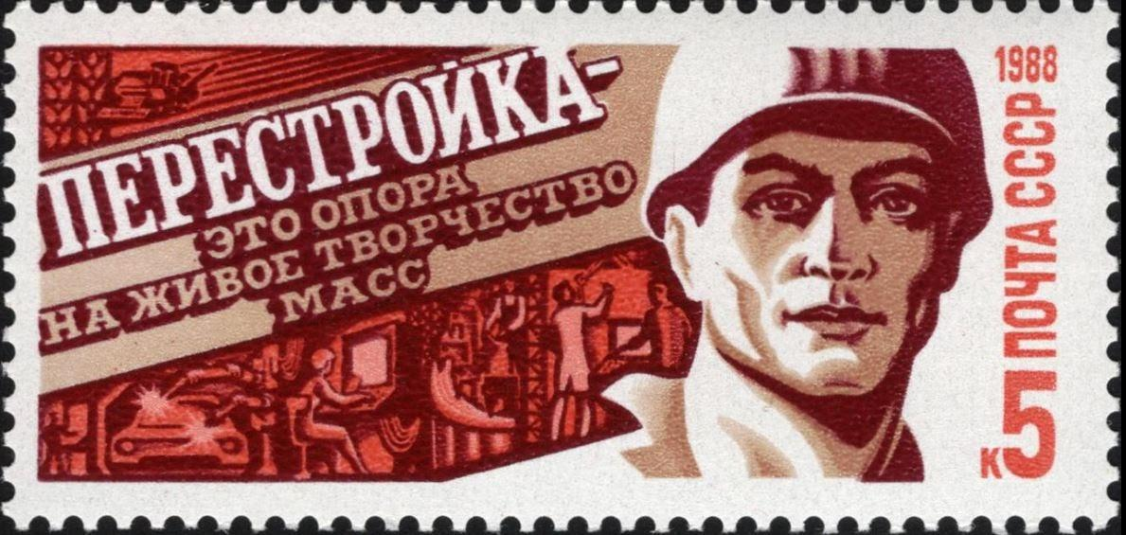
Perestroika postage stamp, 1988 | USSR Post

Materials and Resources:
- Handout: Glasnost, Perestroika, and Politics
- Map: Cold War in Europe
- Michael J. Hurley Oral History excerpt (Glasnost and Perestroika) | Association for Diplomatic Studies and Training
- Georgy Shakhnazarov’s Preparatory Notes for Mikhail Gorbachev for the Meeting of the Politburo | Wilson Center Digital Archive
- Historical Thinking Chart for Primary Sources
- “Perestroika and Glasnost” | History.com.
- “What is the Difference Between Communism and Socialism” | Investopedia.com.

Additional Resources:

- “Reasons for the Cold War” | BBC News.
- "Nixon at War" podcast series | PRX {this podcast series includes original audio from several ADST oral history interviews}
- Video: “Teaching with Primary Sources” | Library of Congress.
- Video: “Analyzing a Primary Source” | Library of Congress.

Lesson Procedure:

- Introduce background information on the Cold War. Display map to show the physical boundaries that represented the Iron Curtain. Play this video to give further background information on the Cold War. Briefly discuss the main ideological and structural differences in communist versus capitalist governments.

- Activity: Compare and Contrast
  - Partner students with fellow classmates to create a Venn diagram from page 2 of the Glasnost, Perestroika, and Politics handout with the political and economic policies of communism vs capitalism.
  - What are the primary differences? Where do the policies overlap?
    - Possible answers include:
      - Communism: price controls, government-controlled assets, redistribution of wealth, centrally controlled government, atheism, totalitarianism
      - Capitalism: free market, privately owned property, consumer choice, freedom of religion, federalist/decentralized government structure, democratically elected officials, freedom of speech

- Introduce Gorbachev and define his policies: Glasnost and Perestroika. Ask students to think about how these policies fundamentally changed communist principles, especially its command economy and political system.

- Introduce Primary Sources:
  - What is the difference between a primary and secondary source? Why do we use primary sources in our learning?
  - Students should consider the following when evaluating primary source documents:
    - Bias
    - Time period
    - Context
    - Speaker View
  - Distribute Michael J. Hurley (Glasnost & Perestroika) oral history excerpt and Wilson Center primary source. Ask students to read these over and complete page 1 of the Glasnost, Perestroika, and Politics handout using the historical thinking chart in order to analyze the primary sources.

Lesson Evaluation:

Assessment: 1) How did the students engage with the material while making the Venn diagram? Did the students list multiple relevant examples? 2) Did the students actively participate in the discussion? Did the students absorb information from the lesson? 3) How did the students fill out the handout? Did the students apply information from the lesson? Did the students carefully read and analyze the primary source documents?

Day 2 Lesson Preparation:

Background information: The Revolutions of 1989 and the Fall of the Berlin Wall

Context: Europe was divided by a metaphorical “Iron Curtain” between the Western Bloc, allied with the ideology of the United States, and the Eastern Bloc of communist countries, primarily located in Central and Eastern Europe. A physical representation of the Iron Curtain was the Berlin Wall: a 96-mile-long barrier that divided Western Europe from the Eastern Bloc and also divided Germany itself. However, a series of revolutions and civil unrest in the Eastern Bloc in the late 1980s prompted the fall of the Berlin Wall in November 1989, marking the beginning of the end of the Cold War. Following this event, the Eastern Bloc and Warsaw Pact unraveled, which led to the eventual dissolution of the Soviet Union by 1991. Today’s lesson includes primary sources detailing the fall of the Berlin Wall and revolutions in Hungary, the Czech Republic, and Romania.
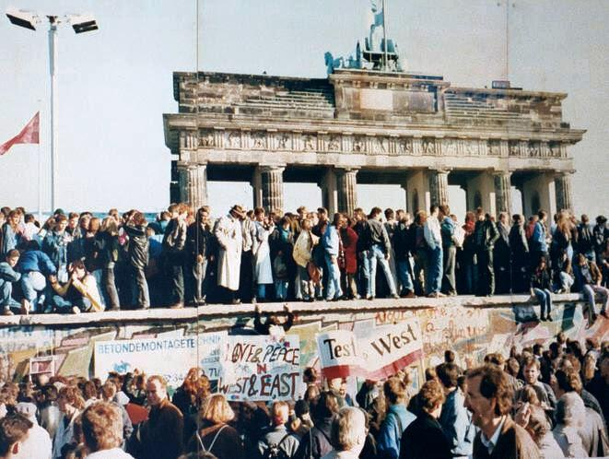
The fall of the Berlin Wall, 1989, at the Brandenburg Gate | Atlantic Council

Materials and Resources:
- Handout: Revolutions in the Eastern Bloc
- Germany: Ambassador J. D. Bindenagel Oral History excerpt | Association for Diplomatic Studies and Training
  - Germany: James Alan Williams Oral History excerpt | Association for Diplomatic Studies and Training
- Romania: Frederick A. Becker Oral History excerpt | Association for Diplomatic Studies and Training
- Czech Republic: Theodore E. Russell Oral History excerpt | Association for Diplomatic Studies and Training
- Hungary: Lawrence Cohen Oral History excerpt | Association for Diplomatic Studies and Training
- Video: “How CNN Covered the Fall of the Berlin Wall” | CNN
- “Fall of Berlin Wall: How 1989 reshaped the modern world” | BBC World News.
- “Fall of Communism in Eastern Europe, 1989” | Office of the Historian, Department of State.
- Optional: ADST Oral History Evaluation Worksheet

Additional Resources:
- Video: “The Revolutions of 1989” Radio Free Liberty Europe. The Revolutions of 1989

Lesson Procedure:

- Provide context for the fall of communism in Central Europe and the fall of the Berlin Wall. Ask students to discuss how Gorbachev’s policies discussed in the previous class contributed to the revolutions in 1989.

- Play video: “How CNN Covered the Fall of the Berlin Wall”.

- Activity: Oral History
  - Split students into groups and assign one country and its corresponding oral history excerpt, to each group. Distribute the Revolutions in the Eastern Bloc handout for students to fill out while reading the oral history. Remind students of primary source evaluation techniques learned in class.

    - Ask students a series of questions that puts their newly acquired historical thinking skills into practice. In what time period was your source created? Are there any possible biases in your excerpt? Who is the audience the source is addressing? Have students decide whether or not their source is reliable and why.
  - If time permits, rotate the countries assigned to each group, and repeat. Have each group assign a spokesperson to read their findings aloud to the class. Ask students to have a class discussion comparing and contrasting the revolutions in each country and how they influenced each other.

- Wrap Up/Bonus assignment:
  - Research a contemporary pro democracy movement and write down the grievances of the protestors and what change they are specifically seeking. How does this compare/contrast to the protests against communism in Europe in the 20th century?
    - Answers could include: pro democracy movements in Hong Kong and Belarus; civil rights protests in the U.S. (George Floyd); anti corruption protests in Russia (Navalny)

Lesson Evaluation:

Assessment: 1) When in teams, are students actively engaging with their group members and helping answer the questions on the handout? 2) Did the students present the information in a way that demonstrates understanding of the texts? 3) Did the students listen to the presentations of other students in order to accurately fill out the handout?

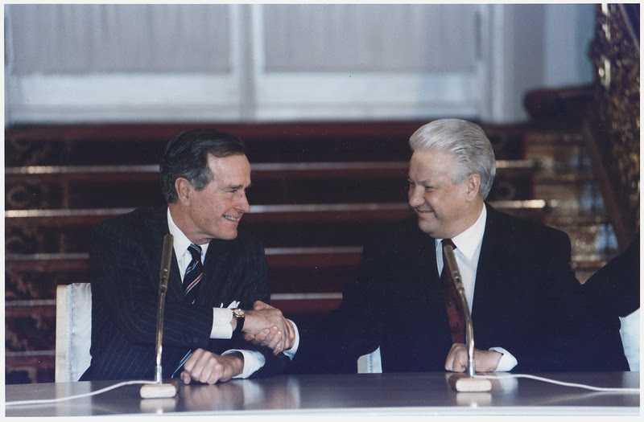
Day 3 Lesson Preparation:
President Bush and Russian President Boris Yeltsin sign the Start II Treaty at a Ceremony in Vladimir Hall | Biddle, Susan

Background Information:

The Fall of the USSR

Context: Influenced by the collapse of communism in Central Europe and the fall of the Berlin Wall, the Soviet socialist republics demanded independence because of dissatisfaction with the communist government and the state of the Soviet economy. Russian hardliners staged a coup in August of 1991 against Gorbachev, which ultimately failed, but drastically weakened support for the government, leading Gorbachev to resign, dissolve the Central Committee, and install Boris Yeltsin as the new president. By December 1991, the Soviet Union broke apart into fifteen newly independent republics, to the surprise of the entire world. In the immediate aftermath of its dissolution, President Yeltsin converted the previously state-owned corporations, farms, and businesses into private entities, though without any uniformity or order. This caused economic turmoil in Russia in the 1990s, effectively allowing new oligarchs and a Russian mafia to run the country, with little regard for rule of law. At the same time, the George H.W. Bush administration was prioritizing economic and political stability and security for the states of the former Soviet Union. The United States recognized the newly independent states and established diplomatic relations. Secretary of State James Baker articulated five basic principles that would guide U.S. policy toward the emerging republics: self-determination consistent with democratic principles, recognition of existing borders, support for democracy and the rule of law, preservation of human rights and the rights of national minorities, and respect for international law and obligations.

Materials and Resources:
- Handout: Fall of the Soviet Union
- Michael J. Hurley Oral History excerpt (Collapse of USSR) | Association for Diplomatic Studies and Training
- Podcast: Naomi Collins: The August 1991 U.S.S.R. Coup
- Ambassador James F. Collins (Collapse of USSR) Oral History excerpt | Association for Diplomatic Studies and Training
- Ambassador William Green Miller Oral History excerpt | Association for Diplomatic Studies and Training
- Ambassador Thomas R. Pickering Oral History excerpt | Association for Diplomatic Studies and Training
- Ambassador James F. Collins Oral History #2 excerpt | Association for Diplomatic Studies and Training
- US Department of State Website
- “The Collapse of the Soviet Union” | Office of the Historian, Department of State
- “Collapse of the Soviet Union” | History.com.

Additional Resources:
- “Diplomacy” | National Geographic.
- “What is Diplomacy?” | Department of State.

Lesson Procedure:

- Introduce context of the August 1991 coup and the attempted ousting of President Gorbachev. Students can use this website that provides a brief overview of the 1991 coup and President Gorbachev.

- Discuss the role of the State Department and diplomacy. See State.gov/about/ for more details.
  - What is a Foreign Service officer?
  - What are the main functions of a U.S. diplomat?
    - Answers can include: representing and defending American interests abroad; promotion of friendly relations; negotiations on political, economic, or military matters; reporting of information; facilitation of agreements.

- Assign ADST oral history excerpts of Michael J. Hurley (Collapse of USSR), Ambassador James F. Collins (Collapse of USSR), Ambassador William Green Miller, Ambassador Thomas R. Pickering, and the Naomi Collins podcast as homework (recommended for time purposes). If you choose to do this activity in class, distribute the excerpts for students to read along and discuss. Then split the students up into smaller groups, have them jigsaw their readings, and present their person to their small group.
  - Use the Fall of Soviet Union handout to answer questions from the oral histories. Ask students to partner with fellow classmates to answer questions and discuss as a class.
    - Discuss how diplomats played a role in the collapse of the Soviet Union. What important contributions did diplomats make behind the scenes? Refer to Ambassador James F. Collins’s oral history excerpt #2.
    - Discuss the role of a Foreign Service spouse. How was Naomi Collins's experience of the 1991 coup similar or different from that of Ambassador James F. Collins’s?

- Activity: Debate
  - Have students debate on what they believe was the primary reason for the collapse of the Soviet Union.
  - Break up students into groups: economic, political, or social causes.
  - Ask students to consult with group members on their argument on why their symptom is the main cause, encouraging students to use primary sources in their arguments. One student from each group should take notes and another should be designated as the spokesperson.
  - Reconvene for a roundtable debate with all three groups. Allow each group to offer an argument and rebuttal.

- Wrap Up:
  - How have U.S.-Russia relations changed since the Cold War era?
  - What are the students' key takeaways from the Fall of Communism lesson?

Lesson Evaluation:

Assessment: 1) Did the students engage in the debate in a respectful manner? Did the students contribute to the discussion? 2) Did the students give examples from readings and previous course material to explain what they thought the cause for the collapse of the Soviet Union was? 3) Did the students have any takeaways about the role of diplomats during the Cold War?

Credits:

Katherine Camberg, Anya Gorodentsev

Handouts:
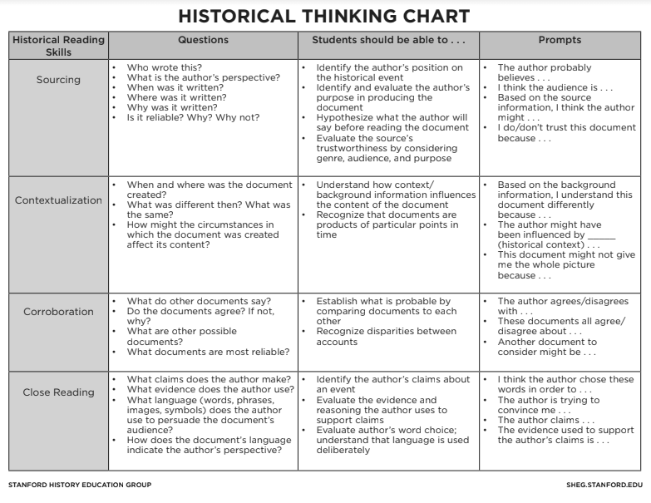
Name _________________________ Date _____________

Glasnost, Perestroika, and Politics Handout

- Define Glasnost and Perestroika

- What was changing in the Soviet Union and the Eastern Bloc in the 1980s, to prompt Gorbachev to initiate Glasnost and Perestroika?

- What were the proposed changes to the economic and political situation in the USSR in these two policies? Were they successful?

- Compare and contrast the politics/economies of the communist vs. capitalist governments. What is similar about them? What is different? How, if anything, did these differences change after Glasnost and Perestroika?

COMMUNIST CAPITALIST

Name _________________________ Date _____________

Revolutions in the Eastern Bloc Handout

Read ADST Oral History excerpts and Answer Questions Below:

- Why was the Berlin Wall erected in the first place? What symbolism did it hold?

- What caused the revolutions? What were the citizens of these countries demanding from the Communist governments?

- What impact did the fall of the Berlin Wall have on the people outside of Germany, living in the Eastern Bloc?

- What was the experience of diplomats like, during these revolutions?

- How was the revolution in Romania different from the other revolutions?

- Bonus: current events: Which protest movements for democracy are happening today? Do you think these movements influence one another?

Name ___________________ Date _____________

Fall of Soviet Union Handout

After scanning the Oral History excerpts, answer the following questions:

- What happened to the Russian state and economy after the dissolution of the Soviet Union? Was the economy better off?

- How did Ambassador James F. Collins experience the collapse of the USSR compared to his wife? What is the role of the Foreign Service spouse?

- What was the role of diplomats and U.S. embassies in the former Soviet states, immediately after the dissolution of the Soviet Union? What was the new relationship between the U.S. and Russia?

Oral History Excerpts:

Michael J. Hurley Oral History excerpt (Glasnost & Perestroika)
Those were the Gorbachev years, so yes things began to change politically. The years of this openness (glasnost) and rebuilding (perestroika) that Gorbachev promoted to reform communism and give it a more human face. Of course in the end it failed and communism collapsed. But to answer your question there was a huge change in the attitude of people, for instance who came through the exhibit. Because when I was in the Embassy from 1987 to 1990 I was responsible for advancing the exhibits. I was the Embassy’s liaison with the guides. The difference in the questions we observed was enormous. In the 1970s they would try to trap us with questions and in the late 80s it was completely reversed where they were asking leading questions. “Isn’t it true that you can buy fifty different types of blue jeans?” I agreed with them, but tell them also that I don’t need 50 different types of blue jeans. You had to try to play down their enthusiasm. They had an exaggerated view that everything is so poor and so bad in the Soviet Union that it must be heaven on earth in the United States. Of course it wasn’t and it isn’t.
On the other hand, we used to get all kinds of agitation and propaganda thrown at us in the 70s. “Why do you hate black people? Why are so many people poor in the U.S.? How much money do you make?” These are questions that were legitimate from their point of view, but of course don’t tell the whole picture about the U.S. One difficulty was to try to give some perspective on race in the U.S. and why there is poverty and crime. It was a great experience for me as a young person to debate with people whose questions were political and aimed to embarrass, whereas we argued only from the point of view of seeing things the way we actually saw them. Arguing with those who don’t care about facts, only winning, as we do in our current Presidential sweepstakes, certainly improved my Russian. OK, that was the 70s.
Source: Michael J. Hurley Oral History, Association for Diplomatic Studies and Training (ADST)

Michael J. Hurley Oral History excerpt (Collapse of USSR)
The Collapse of Communism: By the late 1980s people were just most weary of the whole communist shtick. It was by then hard to find a true believer, because people realized that what they talked about and the application of Leninist theory brought them nothing, and they were tired of it. Information began to travel faster and faster in those times and people could see on their televisions, they could see western movies, that people lived pretty well elsewhere. So the material differences bothered them because Russians are huge materialists. They like things, fancy things.
The Start of Something New: Yeltsin was on the march and big unpredictable changes were coming. We didn’t know which way it would go. We didn’t know that it would all come down. People began to be surprised by how flimsy the foundation was. They always thought that communism, space travel and all of this stuff equaled power. Being there and seeing it up close, I sometimes thought: what is this based on? People are drunk all the time, and they have nothing to buy. They are jolly people—they love to sing and dance and read poetry, but also so dour. Why are we afraid of these people? I don’t think there were more than two or three U.S. analysts who imagined it would all collapse. If anybody says they did anticipate the collapse, they are probably full of it. Just this massive whoosh, and practically everything disappears. And then it wasn’t violent. There was a little bit of violence but it wasn’t massive head beating revolutions. I saw some of the first demonstrations in 1990 with 100,000 people in the streets of Moscow. What is going on here? Big changes were coming.
Source: Michael J. Hurley Oral History, Association for Diplomatic Studies and Training (ADST)

Ambassador J.D. Bindenagel Oral History excerpt
The division of Berlin, symbolized by the Berlin Wall, was for us a deeply terrorizing reminder of man’s inhumanity to man. During the first year of the Berlin Wall more than 50 people died trying to escape the communist paradise. On August 17, 1962, 18-year-old East Berliner Peter Fechter tried to escape near Checkpoint Charlie. As he climbed the Wall, his own East German border guards shot him. For hours he lay helpless and unattended at the foot of the Berlin Wall while he bled to death. The worldwide rejoicing at the fall of the Berlin Wall on November 9, 1989 was easily understood everywhere as an end to this affront to the dignity of human beings everywhere.
Throughout its 28-year existence, the Berlin Wall divided, but did not conquer the spirit of the Germans in the German Democratic Republic. The end of the Berlin Wall brought a new, reborn Germany – the Berlin Republic – dedicated to human dignity, founded in democratic institutions of the Bonn Republic and the democratic revolution in East Germany….
Throughout the year 1989, dramatic events stirred a new sense of freedom in the world and challenged the cold war. Soviet President Gorbachev began his glasnost [restructuring] and glasnost [openness] experiment. Students in China demonstrated for democracy on Tiananmen Square and were brutally crushed by communist tanks. In the two Germanys 2 million soldiers still stood face-to-face across the Berlin Wall ready for war.
On the night of November 9, 1989, the entire world held its breath waiting for the Soviet tanks to roll and crush the German revolutionaries as they had done in 1953. Although the Soviet tanks did not roll out, revolution has changed our world.
The United States throughout the Cold War preached self-determination in an effort to promote democracy movements and stationed millions of American soldiers in West Germany to deter a communist attack. East Europeans had repeatedly tried and failed to find freedom and break the yoke of communist rule. Despite failed attempts in East Germany in 1953, in Hungary in 1956, in Czechoslovakia in 1968, and in Poland in 1980, in the summer of 1989 the Central Europeans tried again…
He rushed to the western side of the Brandenburg Gate to announce to the world that the Berlin Wall was open. The East Germans heard; “Travel to the West is possible immediately.” The revolution, once remarkably controlled, with its Monday night demonstrations in Leipzig and Dresden, seemed to be spinning out of control…
While we were hunting down the travel law text, the first East Germans, attempting to cross without visas, were sent back home by the guards at Checkpoint Charlie who told them to first get visas. It seemed to us that the GDR guards could keep things under control, while the new procedures were being worked out.
With the text of the announced freedom to travel and emigrate in hand, we translated it and cabled it to Washington. I telephoned the White House Situation Room and State Department Operations Center to make sure they had the report and to alert them to the latest developments. Then I called Ambassador Barkley and the American Minister in West Berlin Harry Gilmore, and we diplomats shared our quick assessment of the Politburo announcement. We thought the East Germans would get their visas and then head to West Berlin. Little did we know how quickly the East Germans would test the will of the border police to let them leave and return.
Source: Ambassador J.D. Bindenagel Oral History, Association for Diplomatic Studies and Training (ADST)

James Alan Williams Oral History excerpt

WILLIAMS: I don’t think anybody on the scene in Berlin and perhaps even in Bonn who was following this issue as it developed in the summer and fall of ‘89 anticipated what happened. In retrospect, it looked so clear, and you wonder how we missed it. But if anybody anticipated such a thing he didn’t report it, or at least I never saw the report. We were all too close to it I think. There had been concern for several months that the East German regime was getting wobbly. A lot of its young people were leaving or trying to leave and this accelerated in the late summer and early fall of ‘89 when Hungary opened its border with Austria. There was as I recall regime change in Hungary. They decided to open their border with Austria and take the barbed wire down and this was broadcast as straight news in the West German and East German medium. East Berliners got both. And they quickly realized that as Hungary was still a communist country, formally speaking, they could go there as tourists and then very easily cross over into the West through Austria. And so a number of them started doing that. Numbers of East Germans were leaving East Germany through Hungary to Austria to West Germany in effect... Numbers started going out through Czechoslovakia as well. There was a time when the West German embassy in Prague was inhabited by several thousand East German refugees who had gotten into Czechoslovakia, another communist country, legally as tourists from East Germany but had not been given visas by West Germany, yet nevertheless they climbed over the fence and camped there.

Source: James Alan Williams Oral History, Association for Diplomatic Studies and Training (ADST)

Frederick A. Becker Oral History excerpt

I visited Romania on an orientation trip in November of 1988, having just come onto the desk, and found it if anything a great deal bleaker than it had been when I had served there in the ‘70s. Bucharest was always bleak. They burn a lot of soft coal and in the wintertime the environment was sooty and murky 24 hours a day. The fact is that the Ceausescu regime deprived the population of all of the basic comforts, heat and light in the dark days of winter and certainly any kind of quality food products on the shelves.
But nobody at that time, not even the Romanian desk officer, could predict that Romania any time soon was going to go the same route as the neighboring countries. Again, Ceausescu had built up his own system of repression and control which was not dependent on the winds of change in the rest of the East Bloc, and those controls were remarkably effective. There was no visible magnet for opposition and the population appeared to be thoroughly beaten down by their circumstances….
Romania was celebrating its national day in the great plaza in Bucharest… What happened was a groundswell of protest, quite spontaneous, in which Ceausescu was shouted down by the hundreds of thousands of people who had been summoned... to be the passive witnesses to this repetitive call to national unity and follow-the-leader. He was in fact shouted down. He ended up retreating back from the balcony, while the police and security forces stepped in and quelled an incipient civil protest for the first time in anybody’s memory. This happened about six or eight weeks before the roof ultimately collapsed in December….
After this national day surprise, the embassy started to gear itself up for what could be more of the same. There emerged a general consensus on the desk, in the analytical community and from embassy reporting that unlike the rest of Eastern Europe, if anything happened in Romania it would not be evolutionary or nonviolent because there was no basis for a revolutionary, nonviolent transition in the Romanian context. It was either going to be more of the same, and we were still betting that it was going to be more of the same, or it was going to be violent and nobody was prepared to predict how that might turn out.
In Timișoara, there was a clash between local security forces and elements of the local populace. I seem to think there had been a spontaneous demonstration, a march to a cemetery to pay homage to some citizens who had fallen victim to security police excesses. The march was repressed violently. This time the whole province blew up and indeed it spread to other provinces.
In a matter of days, and it was very difficult to get news out on what was going on, the entire country was literally up in arms – of 40 provinces, well over 30 of them were engulfed in popular revolt. The word of one uprising spread from region to region, and people shed their fear of the authorities and rose up.
The Ceausescu regime took its usual take-no-prisoners and give-no-ground approach to these uprisings and ordered the security forces to do whatever damage they could to break the will of this incipient uprising. Blood flowed.
We found ourselves in Washington dealing with a major bilateral crisis that would become a major international crisis. You not only had the prospect of widespread violence within Romania that conceivably could spread to other countries where ethnic ties were strong, but you also had a sizeable U.S. and international community in Romania that was very much threatened by the domestic violence. Nobody was pointing a finger at the Americans for having provoked any of this, but in fact we were there and we were very visible….

Source: Frederick A. Becker Oral History, Association for Diplomatic Studies and Training (ADST)

Theodore E. Russell Oral History excerpt
I remember going to a movie, called “Five Prague Pieces” I believe, where one of the vignettes was of a Communist movie critic who was discussing a film and progressively getting drunk and talking in Marxist jargon. He was smoking a cigarette and ashes gradually covered his shirt front. By the end he was just babbling. It was very unusual to see a film making fun of Communist jargon and depicting this guy as kind of a clown..
It was true that the Husak-Jakes regime was hopeless, but essentially Gorbachev pulled the plug on them, and because they had no real credibility or popular support in Czechoslovakia, as soon as the Soviet protective shield was lifted by Gorbachev, they crumbled when mass demonstrations broke out.
It was clear that Gorbachev was trying to get the message across with perestroika and glasnost and the promise to withdraw some Soviet forces from East Europe. What really caught our attention was when Hungary opened its borders and let East Germans escape into Austria...
At that point it became pretty clear that the Communist Party apparatus had lost control. The Communist Party Politburo leadership had already resigned and then other hardliners, including [Miroslav] Stepan, the hardline Prague party chief, quit before the general strike.
In Slovakia you had a major demonstration the previous year in March. It was a demonstration in Bratislava demanding religious freedom involving peaceful demonstrators with candles. The police broke it up violently, beating the demonstrators with truncheons. When the mass demonstrations broke out in Prague after November 17, 1989, you had similar but smaller demonstrations starting in Bratislava. What happened in Prague was literally that leading dissidents like Havel, supported by theater directors and actors, dissident intelligentsia and university students came together in theaters across the city. Every theater was packed and dissident spokespersons went on the stage to formulate demands, including the end to the leading role of the Communist Party…The Berlin Wall came down November 9 before the November 17 Czechoslovak revolution started…
On December 10 a new, non-Communist majority government came in and locked in the transition from Communist rule. Then, when Havel came in as President at the end of December 1989, what we saw was a situation, replicated throughout Central Europe, of a total change in our diplomatic opportunities.
Source: Theodore E. Russell Oral History, Association for Diplomatic Studies and Training (ADST)

Lawrence Cohen Oral History excerpt
The country was undergoing a dramatic transformation. Superficially, the political conversion was relatively quick -- that is, the transformation from a communist to a democratic system. The political revolution happened quite rapidly in Hungary and with little upheaval. But Hungary’s economic and social transition had barely begun. As the EST, the Environment, Science and Technology, attaché, I focused on the country’s social and economic transition as experienced by the scientific community. Hungary was undergoing the movement from the communistic centralized system of science to a Western model. I suspect the reason that the EST job was suddenly so popular was that smart FSOs realized that it was the right place to be in the early 1990s. To assist Eastern European science, the USG launched joint scientific and technology funds with the Poles, the Czechoslovaks, the Hungarians, and the Yugoslavs. The Polish and Yugoslav funds had been established years earlier...Many official visitors arrived each week in Budapest, CODELs and cabinet level visits. President Bush had been there earlier. Vice President Dan Quayle came in 1991. Hungarians had an extremely positive attitude about the United States...

Since World War II, and probably before, scientific administration had been centralized within rigid bureaucratic structures. Scientific decision-making, allocating funding for research, was not made on the basis of the caliber of the science. There was no peer review structure, no competition based on scientific merits of the research. Support for research was predicated on nonscientific reasons, including political. Although top notch, Hungarian science had drifted during communism. Funding under the communist system was channeled through research institutes, not universities. All scientists were starved for research funding, some more than others. Institute administrators controlled money received from the central government. The bureaucrats held all the cards. No logical mechanism existed to weigh competing scientific research requests and allocate resources. Hungarian scientists were quite frustrated. Hungarian science stagnated. We come to 1991. A bilateral agreement had been signed the previous year to create the U.S.-Hungarian Science & Technology Joint Fund for research. The USG agreed to provide one million dollars a year, the GOH put up the equivalent in forints, the Hungarian currency. A joint committee consisting of Hungarian ministry and U.S. agency representatives of both countries determined which projects received funding. The committee met twice a year. Funds were used by the scientists to travel to the other country. Hungarian scientists utilized funds for various add-on costs...

When speaking about the environment, I must describe the Gabcikovo Dam controversy. A treaty signed in 1977 by communist Hungary and Czechoslovakia governed the hydroelectric project...A nascent Hungarian NGO called the Danubian Circle was formed in 1984 to oppose the project. From humble beginnings, the Gabcikovo-Nagymaros controversy eventually catalyzed by the late 1980s anti-government protests in Hungary and led indirectly to the fall of the communist regime. The popular anti-Nagymaros movement was a new convulsion for Hungary, for Eastern Europe for that matter. The environmental movement was grassroots and emotional. After staging the largest protest in Hungary since the 1956 Revolution, the NGOs succeeded in forcing the Hungarian Government to suspend its half of the project at Nagymaros. Soon after, the government announced that Nagymaros would not be completed. It was a fairytale success story for the environmentalists and led to a softened approach by the regime to popular dissent…

There was, as I mentioned earlier, a deep antipathy between the Hungarians and the Soviets. The Hungarians just wanted to be rid of the Russians. “Just leave and do not let the door hit you in the face when you walk out.”

Source: Lawrence Cohen Oral History, Association for Diplomatic Studies and Training (ADST)

Ambassador James F. Collins (Collapse of USSR) Oral History excerpt
On the morning of the nineteenth of August at about three minutes after seven I had a call from one of my political officers Ed Salazar who said, “Have you heard the news? You better turn it on.” The radio in the voice any Moscow veteran knew well was announcing that Gorbachev had been temporarily relieved of his responsibilities as president for reasons of health, and an extraordinary committee (the Russian was GKChP) was taking charge of the government. Vice President Yanaev was heading the committee and serving as acting head of state. There followed a bunch of orders and the obligatory martial music that anyone familiar with Soviet practice knew normally accompanied either death of a head of state or signaled a change at the top. End of vacation! My immediate reaction I remember was “OH (expletive),” and we were off to the races….
The issue for us thus became how did we deal with issues absent clarity about who was legally in charge in Moscow or at least would be taken as such. What would we do in the event, which I thought almost certain, we were approached by the leaders of the GKChP in a manner that would require us formally or informally to recognize their authority. These issues were not, of course, discussed in a vacuum. We all understood that the leaders of the GKChP were led by Gorbachev’s opponents and that this was the effort to halt Gorbachev’s effort to reform the Union. That morning, as Chargé, after consulting with my colleagues, I guess I made the one significant foreign policy decision I ever actually made on my own. I decided that we, the embassy, would have nothing to do with GKChP or representatives of the Soviet Government
In the meantime, developments progressed quickly during the early morning. The Ministry of Interior divisions were beginning to stream into town deploying into the city center around the Kremlin and to the area of the White House located right across from the embassy compound. We also learned that Yeltsin had arrived at the White House, and was contesting the action of the self-proclaimed committee in the Kremlin. He had announced he did not recognize the GKChP’s authority, said their action was illegal, and famously atop a tank announced he would oppose them. That set both the policy and physical framework for the entire situation we found ourselves in over the next three days.
We didn’t know whether the junta was going to try a military assault on the White House. Everybody agreed it was fully within their capability to do it, and few thought the resistance could prevail if they did. They also agreed it would be very violent, bloody, and dangerous for us and all others in the area, and would have very nasty consequences. In the end, of course, no assault came. Just why no one knew at the time: perhaps they couldn’t count on their troops to fire on their own people, perhaps they feared the consequences of a military conflict between different parts of the military, which was certainly possible given what was around the White House: perhaps they just could not launch a bloodbath. Historians will have a lot of documents to mull over about this decision. In any event, the military assault did not come, and we came through the coup safely. As the second day came to an end, it was pretty clear that the junta was in trouble, and as we awoke on the third day, there were signs things were beginning to unravel.
Source: Ambassador James F. Collins Oral History Part 1, Association for Diplomatic Studies and Training (ADST)

Ambassador James F. Collins (Collapse of USSR) Oral History excerpt

COLLINS: Let’s recall the point that the collapse of the Soviet system came as much as a shock to everyone in the Soviet republics as it did to the Russians, Americans and Europeans. Candidly, no one was prepared for it, and so far as I know no one had meaningful contingency plans. So from the outset in 1992 we were all making it up as we went along. This was as true of all the leaders in the former republics, now independent states, as it was for Washington and Moscow. But the U.S., even so, did take steps with profound implications for the future of greater Eurasia. I noted earlier the U.S. immediately recognized each of the non-Russia republics as a sovereign, independent state and member of the international community. We then proceeded to establish diplomatic relations and representation with each. The immediate effect of all this on Embassy Moscow was to curtail our formal responsibilities in Eurasia. We now had responsibility for the Russian Federation only. So far as the other new states we kept abreast of what Moscow was doing with them as now “foreign policy”, and did what we could informally to support building of U.S. relations with the new states. It was a limited function but significant.

For one thing, as I recall, a few embassy staff members who had been our circuit riders for Soviet republics were snatched away to help establish relations with the new states. In many cases they were among a very few official Americans with any contacts in the new capitals. The embassy also made a conscientious and sustained effort to develop relations with the representatives the new states had in Moscow - mostly former representatives of the leaders of the republics in the capital. With them we did what we could to facilitate communications with Washington for their governments, provide information, at times just provide personal support, and, as we could, give them advice on practical matters. But, we were also conscious of the need to avoid any implication that we, as America’s embassy to Russia, had any official responsibility for U.S. relations with the new states or saw Moscow as retaining authority over them. It was a bit of a balancing act. We were often sought out by the representatives of new states for personal, informal advice, finding the right contacts with Washington, and such. But, from the beginning of 1992, Embassy Moscow was not really engaged directly with the governments of the new states. That was the job of the new missions we sent there and Washington. So, even as we were focused on Russia as the Embassy in Moscow, we also had a role, often tangential or supportive, in advancing the U.S. policy of promoting the breakup of the USSR in a peaceful way into a community of independent nations.
Source: Association for Diplomatic Studies and Training

Source: Ambassador James F. Collins Oral History Part II, Association for Diplomatic Studies and Training (ADST)

Ambassador William Green Miller Oral History excerpt

The battle for the survival of the Soviet Union was personified in the rivalry between Gorbachev and Yeltsin. I was there, in the Kremlin, in the Great Hall, when Gorbachev came back from the coup attempt in August. Yeltsin received him on the stage with such visible great contempt, at the swearing-in of Yeltsin as President of Russia. I was present at the trial of the Communist party, which was held in the former offices of the Central Committee, which was then being transformed into the offices of the Constitutional Court. And I was present at committee meetings of the Supreme Soviet on human rights and arms control….
Marxism was still deeply held. The Gorbachevian proposition was that Marxism could be reformed, that the era of change was necessary because of the failure of Stalin and his regime’s brutality. The 1968 Czech Prague uprising had a profound effect on Gorbachev. The idea that it was necessary for socialism to have a human face was then widely believed. It is still a strong element of belief in Russia, and as I found, in Ukraine. He believed in reformed Marxist solutions, he believes in it to this day. It’s still a strong school of thought in all of the former Soviet states – although it is a minority view, whereas it was once the only permitted view.
The hardliners, who were in charge of the security organizations, were the holdouts, but in the perestroika [“restructuring”] time, they were the ideological minority, although they were in charge of the security ministries. The August coup of 1991 was their last attempt to maintain control. And that was the question, whether the ideological change, the “new thinking” so called would prevail, or whether the hard-liners would allow the change to take place….[T]he futile, comic coup attempt, by the pathetic coup group, was a clear sign the change was irreversible. The Stalinist hard-liners didn’t have the conviction that a militant group in charge of the power and security ministries in the past would have had.
The children of the Bolshevik Revolution had a different idea. The failure of Gorbachev to handle the expectations and demands of the intellectuals, the inability to control or at least steer the new freedom that had been acquired by the younger generation, was the main reason, I think, for the end of the Soviet Union. Gorbachev couldn’t accommodate or adapt fully enough to the consequences of this new freedom….
This was a hell of a time to be in Moscow as a Foreign Service officer, as an NGO president, as I was, as a journalist, as a tourist. It was an extraordinary moment and a great expression of the best in the human spirit…
The fall of the Berlin Wall cannot be understood by itself. The impact of the 1968 Prague uprising on Gorbachev, the power of the human rights movement and the example of people liked Andrei Sakharov…all contributed to the eventual fall of the Berlin Wall. But most important was Gorbachev’s decision that people of each nation will make their own decision about the government they want to have.

Source: Ambassador William Green Miller Oral History, Association for Diplomatic Studies and Training (ADST)

Ambassador Thomas R. Pickering Oral History excerpt

When I was there at first there were all over Russia people who were deeply anguished by the loss of the constituent republics of the former Soviet Union -- places like Kazakhstan, Uzbekistan, Georgia, Ukraine, Moldova and the Baltic States. They saw this as the beginning of what one could say was the unhinging or the disintegration of the Russian Federation. The Russian Federation has 89 constituent units to it, 22 of which under Stalin were in effect republics -- the higher grade of administrative subdivision -- they had their own flags, anthems, and presidents which were mainly based around ethnic minorities. Some of them pretty nominal….

And to some extent it comes from first the notion that when Communism collapsed there were no rules for the operation of an open market. Now Adam Smith would tell you by definition there should be no rules. But we all know, in fact, that a successful operation of capitals economies depends very heavily on government ruling making and regulation. They don’t depend so much on what the Soviets saw which was the governments producing goods and services. So as the Russian economy shifted from the government production of goods and services, it was suddenly one day a complete prohibition against private enterprise and suddenly the next day there was full permission for private enterprise with no set of balancing rules and regulations. These covered meeting health requirements or dealing with their labor or, you know, how to operate in the market or whether trusts were or were not possible, whether prohibited market practices, strong arm enforcement or anything should be outlawed. So in effect you went from total prohibition to Wild West overnight. Russians are not dumb and the most successful are smart as hell and learned how to take advantage of all of this, including the fact that they learned all the tricks and invented new ones in order to amass large amounts of personal wealth to build their fortunes...

In the meantime, the Russians have begun to pass laws regulating business, but it’s not in my view necessarily too far still from the Wild West. There are more obligations of responsibility and in the end in Russia having no rules to run the economy meant that the government could do what it wanted. It was not bound by a rule of law in the way it could use all the elements of state power and all of the traditional activities say of the intelligence and security agencies to put pressure on the oligarchs.

Source: Ambassador Thomas R. Pickering Oral History, Association for Diplomatic Studies and Training (ADST)

